

Dissertation Title: Exploring the Impact of Wearable Fitness Tracker Data on Lifestyle Changes Among Urban Adults Aged 25–45: A Case Study in Mumbai, India.

Master title: MSC Data Analytics

Name: Prasad Naredla

Year: 2025

ABSTRACT

CONTENTS

ABSTRACT I
CONTENTS II
FIGURES VI
ACKNOWLEDGEMENTS VII
DISSERTATION THESIS IX
INTRODUCTION 1
The Study Overview and Background 1
The Problem Statement 2
Research Aims and Objectives 2
The Research Aim 2
The Research Objectives 2
Overview of Research Methodology 3
Thesis Structure 4
1. CHAPTER ONE – LITERATURE REVIEW 5
1.1. Introduction 5
1.2. History of the Research 5
1.3. Theoretical Frameworks 6
1.3.1. Social Cognitive Theory (SCT) 6
1.3.2. Self-Determination Theory (SDT) 7
1.3.3. Habit Formation Theory 9
1.4. The Conceptual Framework 10
1.4.1. The Overview of the Framework 10
1.5. The Analysis of the Key Concepts 11
2. CHAPTER TWO – LITERATURE REVIEW II 15
2.1. Introduction 15
2.2. The Adoption of Wearable trackers 15
2.3. Health Impacts of Wearable Fitness Trackers 17
2.4. The Psychological and Behavioral Motivation of Using Fitness Tracking Wearables 19
2.5. The Literature Gap 21
2.6. Conclusion 22
3. CHAPTER THREE – METHODOLOGY 24
3.1. Introduction 24
3.2. Research Design 24
3.3. Research strategy 25
3.4. Target Population and Sampling 26
3.5. Sample Size and Sampling Technique 26
3.6. Data Collection Methods 27
3.7. Reliability and Validity of Data 27
3.8. Data Analysis 27
3.9. Ethical Considerations 28
3.10. Limitations of the Study 29
3.11. Summary 29
4. CHAPTER FOUR – FINDINGS / ANALYSIS / DISCUSSION 30
4.1. FINDINGS 31
4.1.1. Percentages and Measures of central tendency 31
4.1.2. Correlational analysis 54
4.2. ANALYSIS 57
4.2.1. Key Inferences from Findings 57
4.2.2. Linking Findings to Research Objectives 58
4.2.3. Unexpected Results 59
4.3. DISCUSSION 60
4.3.1. Practical Implications 60
4.3.2. Contribution of Study Findings to Existing Body of Knowledge 60
4.3.3. Convergence with Existing Literature 61
4.3.4. Divergence from Existing Literature 61
4.3.5. Summary 62
CONCLUDING REMARKS 63
Summary of Key Findings 63
Actionable Recommendations 63
Support for Existing Literature 64
Limitations of this Research Study 65
Opportunities for Future Research Works 66
BIBLIOGRAPHY 67
APPENDIX 74
Questionnaire: 74
Demographic and Socioeconomic Moderators 74
Physical Activity, Sleep, and Sedentary Behavior 77
User Experiences, Attitudes, and Behavior Mechanisms 79

FIGURES

Figure 1: Duration of Fitness Tracker Use 31
Figure 2: Frequency of Device Replacement 32
Figure 3: Factors Influencing Tracker Choice 33
Figure 4: Sharing Fitness Data with Others 34
Figure 5: Continuation of Fitness Tracker Use 35
Figure 6: Challenges in Tracker Usage 37
Figure 7: Support from Friends and Family 38
Figure 8: Tracker Fit into Lifestyle 39
Figure 9: Frequency of Physical Activity 40
Figure 10: Change in Physical Activity 41
Figure 11: Change in Sedentary Behavior 42
Figure 12: Average Hours of Sleep 43
Figure 13: Change in Sleep Quality 44
Figure 14: Adjusted Lifestyle Habits 45
Figure 15: Frequency of Checking Data 46
Figure 16: Motivation from Tracker Data 47
Figure 17: Consistency in Exercise Habits 48
Figure 18: Reaching Daily Activity Goals 49
Figure 19: Helpfulness of Tracker Reminders 50
Figure 20: Most Used Tracker Features 51
Figure 21: Feelings When Goals Not Met 52
Figure 22: Overall Satisfaction with Tracker 53
Figure 23: Behavioral Changes Due to Tracker 54

ACKNOWLEDGEMENTS

Statement of compliance with academic ethics and the avoidance of plagiarism

I honestly declare that this dissertation is entirely my own work and none of its part has been copied from printed or electronic sources, translated from foreign sources and reproduced from essays of other researchers or students. Wherever I have been based on ideas or other people texts I clearly declare it through the good use of references following academic ethics.
(In the case that is proved that part of the essay does not constitute an original work, but a copy of an already published essay or from another source, the student will be expelled permanently from the postgraduate program).

Name and Surname (Capital letters):
PRASAD NAREDLA
.......................................................................................................................................

Date: 29/09/2025

DISSERTATION THESIS

(leave this page empty)

INTRODUCTION

The Study Overview and Background
In this contemporary age, technology is defining people's lives in a significant way. Digital health systems are leading in transforming the wellness landscape, and wearable fitness trackers, such as smartwatches and wristbands, have emerged as powerful tools for personal health monitoring. The gadgets are used to monitor essential health data, such as steps taken, calories burned, sleep activities, and heart rates, providing them with immediate feedback and goal-setting capabilities (Gonzalez Ramirez et al., 2023). These tools have become widespread around the world, as the functionalities of their fitness tracking technologies are incorporated into the lives of more consumers.
The adoption of wearable technology is also becoming common in India, particularly in the big cities such as Mumbai. In 2023, India emerged as the third-largest market in wearable devices due to low costs and increased awareness of disease prevention relating to lifestyle choices (Patil et al., 2022). The population of urbanised adults with the age range of 25 to 45 is among the primary targets of this trend, as they have been exposed to the solutions that technology has created and therefore, lead a sedentary lifestyle and become increasingly aware of health (Ridgers et al., 2020). Nevertheless, such development has shown that fewer than 30% of wearable users, on average, exercise regularly, and only approximately 40% attain worldwide physical activity recommendations (Patil et al., 2022). In 2019 Brickwood et al conducted a study based in Western settings, which demonstrated a short-term increase in physical activity due to wearable devices, with a standardised mean difference (SMD) of 0.24 to 0.45. However, the sustainability of adherence and long-term behavioural change has been low and less studied, especially in low- and middle-income states. The dynamic and multicultural urban population in Mumbai offers a distinct prospect for understanding how wearable information would impact lifestyle changes in the long run.

The Problem Statement
Wearable fitness trackers are believed to significantly improve lifestyles by increasing physical activity, improving health awareness, and promoting behaviour changes through personalised feedback and goal setting. The available studies are mainly set in high-income countries, which focus on the short-term effect of the wearable fitness tracker; there is no significant evidence on how it can benefit in the long term. Thus, it becomes critical to study beyond the acceptance of these wearables as a health solution, but to study the effect on the health-related behaviour of the users over time. This study aims to link the surge in sales of wearables in India with health impacts such as increasing fitness, improving sleeping patterns, and reducing lifestyle diseases, among others.
Further, this study will dig deep into the behavioural and psychological processes that are involved in (or impede) successful lifestyle change by using wearables, including, but not limited to, habit formation, motivation, and self-monitoring. Moreover, socioeconomic, working culture, and digital literacy are contextual situational parameters that will define the study within the urban Indian environment. Thus, this research comprehensively investigates the research impact of wearable fitness trackers to sustain lifestyle changes in urban adults aged between 25 and 45 years in Mumbai.

Research Aims and Objectives

The Research Aim
The primary objective of this study is to evaluate the influence of wearable fitness tracker data on lifestyle practices, including physical activity, sedentary time, and sleep, among urban adults aged 25–45 in Mumbai, India.

The Research Objectives
- To assess changes in participants’ physical activity levels, sleep patterns, and sedentary time over a six-month period of wearable use.
- To explore user experiences, attitudes, and behavioral mechanisms (e.g., motivation, habit formation, self-monitoring) that influence these lifestyle changes.
- To examine the moderating role of demographic and socioeconomic factors, such as income, gender, and educational background, on the outcomes and sustained use of wearable trackers.

Overview of Research Methodology
This empirical study will employ quantitative research methods using primary data to assess the effect of wearable fitness tracker data on improving a healthy lifestyle among adults in the Mumbai urban area. The study is based on primary data, which will be obtained in the form of a structured questionnaire using Microsoft Forms. The questionnaire will be distributed electronically to 100 respondents of the target sample (25- 45 years old) living or working in Mumbai city. The selection will focus on individuals who actively use wearable fitness devices (e.g., smartwatches or fitness bands) and are able to report on their health-related behaviours such as physical activity, sleep patterns, and sedentary time.
The questions are designed to capture both demographic details (age, gender, income, education) and behavioral indicators (e.g., frequency of wearable use, type of data tracked, changes in health behavior since device adoption). The data collected will be analyzed using Microsoft Excel and Microsoft Forms’ built-in analytics tools, focusing on descriptive statistics such as percentages, averages, and frequency distributions. Cross-tabulation and basic correlation analysis will also be used to explore relationships between variables like duration of wearable use and reported lifestyle changes.

The Research Questions
- Which changes in participants’ physical activity levels sleep patterns and sedentary time over a six-month period of wearable use?
- What user experiences, attitudes, and behavioral mechanisms (e.g., motivation, habit formation, self-monitoring) that influence these lifestyle changes?
- Which moderating role of demographic and socioeconomic factors, such as income, gender, and educational background, on the outcomes and sustained use of wearable trackers?

Thesis Structure
This dissertation is classified into four main chapters; literature review one, is the first chapter of the study, which states the theories and models that relate to the research. The theories and models include: Social Cognitive Theory (SCT), Self-Determination Theory (SDT), COM-B Model (Capability, Opportunity, Motivation – Behavior), Habit Formation Theory, Technology Acceptance Models and Theoretical Locus. In chapter two, literature review two, critically evaluate existing literature to help create foundation of the study. The review is structured around three variables- The Adoption of Wearable Fitness Trackers, the psychological and behavioral motivation of using fitness tracking wearable and lastly health impacts of wearable fitness trackers. Research methodology chapter 3 provide a detailed description of research design, target population and sampling, sample size and sampling techniques and data collection methods used. Chapter 4 findings and analysis explains how data was collected and analyzed. It also lists the collected evidence from the respondents.
Having discussed the background of the study, problem of statement, research aims and objectives, overview of research methodology and research questions we transition to chapter one which is literature review one.

CHAPTER ONE – LITERATURE REVIEW

Introduction
This section provides a critical analysis of the theoretical and conceptual foundations that support the study on the impact of wearable fitness trackers on lifestyle behaviours among urban adults in Mumbai. Though it's the technology that is influencing these health practices, there are existing frameworks that can help understand the behavioural trends that influence the adoption of these mechanisms. Thus, the focus in this case is to evaluate theories on how behaviours are formed and influence certain practices among people. The following theories and models - Self-Determination Theory, Social Cognitive Theory, Habit Formation Theory, will form the basis of the analysis. Further, a conceptual framework will be developed to create a linkage between wearable health products and behavioural practices such as motivation, self-monitoring, and habit formation as mediators between wearable use and health outcomes. This framework guides the empirical phases of the study and aligns with the research objectives targeting lifestyle transformation through wearable technologies.

History of the Research
Over the past 20 years, research on wearable fitness trackers has changed dramatically, progressing from early studies conducted in wealthy nations to more recent studies conducted in developing nations. Early research, which frequently showed encouraging effects on physical activity and sedentary reduction, mainly concentrated on adoption patterns, perceived usefulness, and short-term health outcomes (Manskow et al., 2024). Although wearables increase engagement in the short term, adherence usually decreases after six to twelve months, according to systematic reviews and meta-analyses conducted over time (Alam et al., 2023). More recent research has shown that contextual factors like income and digital literacy, as well as psychological factors like motivation and self-efficacy, are significant predictors of sustained use. Research in India is still scarce, and the majority of studies use cross-sectional or short-term designs, which leaves gaps in our knowledge of long-term behavioral change (Hwong et al., 2022). This study expands on this trajectory by investigating long-term lifestyle changes among Mumbai's urban adults over six months, addressing both behavioral and socioeconomic moderators of wearable engagement.

Theoretical Frameworks

Social Cognitive Theory (SCT)
Social Cognitive Theory (SCT) highlights how behavioral, environmental, and personal factors interact to shape health behaviors. This framework is conducive to explaining changes in physical activity, sleep, and sedentary time among urban adults in Mumbai when it comes to wearable fitness trackers. Trackers improve self-regulation, which is essential to SCT's tenets, by offering real-time feedback and progress tracking (Dekkers et al., 2021). In order to reinforce healthier patterns, people look at their activity data, compare it to their goals, and modify their behavior accordingly. Even with the aid of technology, behavior change may be hampered by Mumbai's urban environment, which includes issues like long workdays, heavy traffic, and a lack of recreational opportunities. This duality is highlighted by SCT, where the interaction of environmental barriers, device cues, and individual motivation determines results. This directly relates to the first research question, which asks how wearable technology affects sleep, activity levels, and sedentary time over time. Therefore, SCT offers a prism through which to assess whether these gadgets only educate users or actively enable them to get around environmental limitations (Mhlongo et al., 2023).
Both SCT and wearable adoption rely heavily on behavioral mechanisms such as self-monitoring, habit formation, and motivation. SCT holds that ongoing performance monitoring and reinforcement help people build self-efficacy, or the conviction that they can carry out health-related actions. Wearable technology helps with this by providing users with instant feedback, incentives, and reminders that boost their self-confidence in their ability to increase activity and sleep quality (Lu et al., 2025). However, whether or not users believe that progress is achievable and significant in their cultural and lifestyle contexts will determine how much these features translate into long-lasting habits. Only when wearables are incorporated into users' current routines, such as tracking steps during commutes or promoting yoga-based activity goals, can they help people form new habits in Mumbai, where stress, lengthy commutes, and sedentary office work are the norm. The second research question, which examines user experiences and behavioral mechanisms influencing change, is reflected in this. SCT enables researchers to evaluate critically whether feedback and self-monitoring increase intrinsic motivation or if they run the risk of discouraging users when they fall short of irrational expectations (Lee-Kan 2024). By doing this, it presents wearable technology as a source of frustration as well as motivation.
SCT has drawbacks when it comes to wearable technology research in Mumbai, despite its applicability. In order to convert intentions into action, the theory presupposes that people always have access to feedback loops, social reinforcement, and environmental support. However, the applicability of these principles in lower socioeconomic groups may be limited by digital divides and unequal access to healthcare infrastructure. Furthermore, when novelty wanes, SCT is unable to adequately account for the long-term motivation and self-efficacy needed for sustained wearable engagement. Mumbai's cultural views on technology and health may also influence how self-control and observational learning are viewed, which could call into question the applicability of SCT principles globally (Deb et al., 2023). According to critical analysis, SCT needs to be modified for local contexts even though it helps comprehend how behavioral, environmental, and individual factors interact. The framework will be used to investigate whether wearable trackers can help Mumbai's diverse population develop sustainable health behaviors and self-efficacy.

Self-Determination Theory (SDT)
SDT is a helpful framework for comprehending how wearable fitness trackers affect lifestyle patterns because it highlights the significance of intrinsic motivation in maintaining long-term behavioral change. According to the theory, human motivation ranges from autonomous motivation—like enjoying oneself or placing a high value on one's health—to external regulation—like social pressure (Deb et al., 2023). Step-count targets, sleep tracking, and sedentary time alerts can support short-term behavioral changes in the context of wearable technology, but their long-term effects rely on whether or not they promote intrinsic motivation. A person in Mumbai, for instance, might use a tracker at first to achieve externally motivated objectives, like competing with friends or completing wellness challenges at work, but sustained adherence necessitates internalized value for health. The first research question, which examines whether wearables result in quantifiable lifestyle changes over six months, is directly related to this. SDT makes it possible to critically examine whether these changes are the result of transient compliance with outside cues or the development of proper habits (Alberts et al., 2024). Additionally, studies indicate that when novelty wears off, devices that primarily rely on gamification or extrinsic rewards run the risk of losing users.
The three psychological needs identified by SDT—autonomy, competence, and relatedness—are also intimately associated with behavioral mechanisms like self-monitoring, habit formation, and feedback. The sense of control users has over their health decisions is known as autonomy, and it can be enhanced when trackers enable goal and feedback personalization (Feng et al., 2021). Competence develops when people feel like they are making progress and mastering a task; this need is frequently satisfied by increasing one's step count, getting better sleep, or spending less time sitting down. The term "relatedness" describes the social ties that are made possible by gadgets, like when peers share their progress or take part in group fitness challenges. Wearables that meet these demands are more likely to maintain engagement in Mumbai, where urban adults deal with high levels of stress and little free time. The second research question, which looks at how experiences, attitudes, and behavioral mechanisms influence lifestyle change, is closely related to this. According to SDT, wearables are more likely to encourage self-sustaining health behaviors if they foster competence and autonomy without applying strict external pressure (Jayarathne 2025). Importantly, trackers who disregard these demands run the risk of raising tension and causing stress or desertion. SDT thus clarifies wearable engagement's advantages and disadvantages.
Demographic and socioeconomic factors also moderate the application of SDT principles to wearable technology in Mumbai. Professionals with higher incomes may feel more competent and autonomous in setting and achieving fitness goals. In contrast, those with lower incomes may find it challenging to afford or use technology, which lessens their sense of control. Because men and women may have different experiences with health behaviors in Mumbai's cultural context, gender differences can also shape relatedness and social influence. An individual's educational background also influences motivation by determining whether they perceive wearable data as intimidating or empowering. This directly relates to the third research question, which asks how socioeconomic and demographic factors influence results. According to SDT, psychological needs are universal, but depending on the supports and limitations of the environment, they may not be met equally by different groups. For instance, users with higher levels of education may benefit from personalized features, but people with lower levels of digital literacy may not use them as much. As a result, SDT emphasizes how socioeconomic context shapes motivational differences rather than just individual differences (Van Elsen et al., 2024). Instead of treating users as a monolithic group, this critical viewpoint helps place wearables within Mumbai's diverse population.

Habit Formation Theory
The theory highlights how long-term lifestyle patterns are shaped by repeated behaviors that are reinforced by cues and rewards. The continuous feedback provided by step counts, sleep scores, and activity reminders in the context of wearable fitness trackers can serve as cues that encourage regular participation in healthy behaviors (Ferguson et al., 2022). Such cues can be crucial in promoting gradual improvements in physical activity and sleep patterns among Mumbai's 25–45 urban adults, who frequently face time constraints and sedentary work environments. However, studies show that in order to transition from intentional behavior to automatic action, habit formation necessitates consistent repetition over an extended period of time, frequently weeks or months. This directly relates to the first research question, which examines the changes in sleep patterns, sedentary time, and physical activity over six months of wearable use. The possibility of long-lasting behavioral change, even when motivation wanes, rises if these devices are successful in establishing routines. However, research warns that in the absence of contextual support or intrinsic motivation, users may stop using trackers before habits become ingrained. Wearables can therefore encourage the development of new habits, but their efficacy hinges on sustained reinforcement and consistency (Akash and Chowdhury 2025).
Habit Formation Theory offers a framework for comprehending how repeated exposure to self-monitoring can affect behavior when examining the psychological processes underlying lifestyle change. Frequent reminders to move or work out, for instance, can initially inspire users, but their long-term efficacy depends on the shift from conscious decision-making to automatic routines. This relates to the second research question because self-monitoring behaviors, motivation, and self-efficacy all interact with habit formation to influence user experiences. The development of healthy routines may be aided or hindered in Mumbai by factors such as daily commuting, long workdays, and cultural customs surrounding food and leisure (Poddar et al., 2025). While some people may find that the urban setting offers plenty of opportunities for walking or other physical activity, others may find that structural factors restrict these activities.
The third research question emphasizes how socioeconomic and demographic factors exacerbate the processes involved in habit formation. With structured schedules and access to fitness facilities, wearable technology may be easier for Mumbai's wealthier and more tech-savvy residents to incorporate into their daily lives. On the other hand, even after using the device initially, users with lower incomes or those with demanding, irregular work schedules might find it challenging to maintain healthy habits (George 2024). According to habit formation theory, routine development is primarily about consistency rather than intensity; however, for some groups, socioeconomic pressures may interfere with this consistency (Fleetwood 2021). This suggests that wearables are not always successful and that users' life circumstances influence their ability to encourage new routines. Furthermore, whether or not habit cues from devices resonate with users may be influenced by cultural views on exercise and health. Therefore, the theory emphasizes the necessity of looking at both behavioral change and how long it lasts in various demographic contexts. Insight into the potential and limitations of wearables is provided by this study's assessment of how they promote or hinder habits across a range of socioeconomic backgrounds in Mumbai.

The Conceptual Framework

The Overview of the Framework
This section presents the conceptual framework guiding the current study on the influence of wearable fitness trackers on lifestyle behaviour among urban adults in Mumbai. The framework is rooted in an integrated understanding of behavioural, motivational, and technological theories, particularly the Self-Determination Theory, Social Cognitive Theory, the COM-B Model, Habit Formation Theory, and Technology Acceptance Models. These theories collectively highlight that technology use alone does not guarantee behaviour change; rather, behavioural transformation emerges through complex interactions between user characteristics, motivational processes, contextual supports, and the habitual reinforcement of actions.
As wearable devices become an integral part of daily health, users use them to provide real-time data concerning the number of steps, hours of sleep, and time spent sitting. Nevertheless, functionality alone does not determine their effects over the long-term practices of behavioural transformation because psychological engagement, user motivation and contextual opportunity, as well as the establishment of healthy habits, are mediators. This framework aims to map such mediators and explain more about the indirect mechanisms of wearables that may affect health-related aspects. It gives theoretical ground to answer the question of not simply whether these technologies bring lifestyle change, but also how and in what circumstances they do so. Hence, it provides a sophisticated insight into technology-empowered health behaviours in a low- and middle-income urban environment.

The Analysis of the Key Concepts
The conceptual framework is based on six core constructs, which are derived from the theoretical synthesis and are essential for understanding the effect of wearable fitness tracking devices on individuals' behaviour, which are described as wearable use, self-monitoring, motivation, habit formation, contextual factors and lifestyle behaviour outcomes.
1.4.1. Wearable Use
The concept of wearable use defines the extent, magnitude, and depth of involvement of these gadgets - this includes time spent, frequency and depth of interaction. The activities these devices are used for include monitoring of physical activity, sleep, heart rate, and sedentary behaviour. Based on the Technology Acceptance Model (Davis, 1989) and UTAUT (de 2023), perceived usefulness and ease of use are the most significant determinants of use associated with the wearable. Such perceptions influence not only the initial adoption but also sustained participation.
1.4.2. Self-Monitoring
Self-monitoring is a behavioural approach through which an individual monitors and takes notes on his or her behaviours in a bid to achieve his or her goals. It has been described as a key variable within action change models like the Social cognitive theory (Bandura, 1997), whose regulation is personal, and the driver is feedback and self-evaluation. Wearables are presented as external self-surveillance devices that expose and reflect a view of the health behaviours to be followed, monitored, and could enhance self-awareness and decision-making.
1.4.3 Motivation
Motivation refers to an internal drive that compels an individual to act or behave in a particular manner - it's a force that initiates and maintains a direction of specific actions. According to Self-Determination Theory (Fradkin-Hayslip 2021). motivation exists along a scale of extrinsic (motivation through reward or social coercion) to intrinsic (motivation through intrinsic interest or personal value). The features of wearables have an impact on motivation that fulfils psychological needs, including autonomy (goal setting is customisable), competence (record of achievements), and relatedness (competition and sharing with friends). The issue of long-term change depends very heavily on autonomous motivation.
1.4.4 Habit Formation
Habit formation is the process by which behaviour becomes repetitive. While motivation may initiate a behaviour, long-term adherence depends on automaticity, i.e., habits. According to the Habit Formation theory, repetitive behaviours in consistent contexts form strong cognitive associations. Thus, this makes individuals begin engaging in physical activity patterns without conscious effort.
1.4.5 Contextual Factors
The contextual factor refers to the element of an environment that influences behaviours, events and outcomes. Based on the COM-B Model (Willmott et al., 2021), the contextual factors are: capability (knowledge and skills), opportunity (time, social support, environmental access) and socioeconomic status They condition the possibility of a motivated individual to act in line with their intentions. The urban context of Mumbai--in terms of density, working culture and digital divide--makes these contextual mediators of particular relevance.
1.4.6 Lifestyle Behavioural Outcomes
This refers to changes in physical activity, sedentary time, and sleep quality over time. These are the observable behavioural outcomes hypothesised to be influenced indirectly through wearable use and the mediating mechanisms above. Based on prior literature (Yang et al., 2024), sustained behavioural improvement is most likely when motivation, monitoring, and habitual reinforcement align under supportive contextual conditions.
1.5 Conceptual Framework Diagram
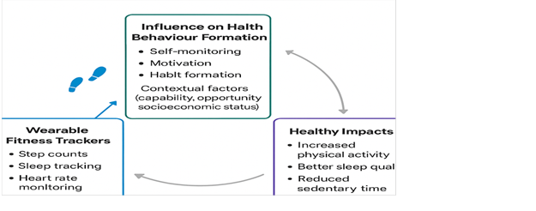

The conceptual framework guiding this study integrates the principles of the behaviour and technology acceptance theories to study the effect that the application of wearable fitness trackers could have on lifestyle behaviours. The centerpiece of this framework is the realisation that behaviour change is a multidimensional, dynamic process molded by a combination of individual motivation, contextual capability, technology usability and reinforcement mechanisms. Based on the Self-Determination Theory (SDT), according to the model, motivation, especially intrinsic motivation, is identified as the main factor in initiating and maintaining health behaviour change. Thus, wearables help to self-monitor/set self-goals, which, when aligned with the feelings of autonomy and ability towards self, create internal drive towards physical activity, food modification, and sleep control.
To understand how these motivational processes work, the COM-B (Capability, Opportunity, Motivation Behaviour) model is integrated into the framework. The wearables serve as both a source of psychological capability, by enhancing users’ understanding of their behaviour through feedback, and physical opportunity, by prompting activity or movement in otherwise sedentary routines. Reflective and automatic would-be motivation through habits and rewards. The behaviour in so doing is therefore not considered an isolated behaviour but a resultant effect of the interactions between the capability, opportunity, and motivation (Oyedele et al., 2024)
The linkage between motivation and behaviour is further explicated by the Habit Formation Theory, which talks about the sustainability of behavioural change. Whilst the motivational power may trigger the initial adoption, the repetition and the stability context crucial to reinforce the new behaviours into automatic responses can be empowered with the help of reminders, gamified feedback, and wearable cues. Wearable trackers, in this regard, do not just track behaviour but mold habits as they progress along with feedback loop reinforcements.
The model is interconnected with the help of Social Cognitive Theory (SCT), which underlines the importance of self-efficacy and social reinforcement. Individuals, who believe they are able to meet health outcomes and have social support, whether in a digital or face-to-face form, will more successfully perform their activities regularly. Normative pressure can be encouraged through observational learning, adding an extra layer of pressure that can bind an individual to adherent behaviour.
In summary, the conceptual framework in this study forms a circular and reinforcing model of behavioural change. Wearable technology acts as a mediator between individual characteristics (example motivation, self-efficacy) and environmental influences (example, social norms, access to space), ultimately influencing lifestyle behaviour outcomes (Rieder et al., 2021). The model anticipates that behaviour change is not linear but cyclical, shaped by feedback and adaptation over time. In examining the urban context of Mumbai, where space, time, and health literacy may present unique constraints and enablers, this framework allows for an empirical investigation into how and under what conditions wearable fitness trackers become effective tools for sustainable lifestyle change.

CHAPTER TWO – LITERATURE REVIEW II

Introduction
This section critically examines existing scholarship relevant to the study of wearable fitness trackers and their role in influencing lifestyle behaviours among urban adults in Mumbai. The review is built on the existing problem and the current trends affecting the purchase and use of fitness tracking wearables. The behavioural and psychological theories set a background for empirical analysis exploring how wearable technologies are adopted, the psychological and behavioural motivations that drive their use, and the health impacts of sustained engagement.
Thus, the review is structured around three overarching concepts. The first concept is The Adoption of Wearables, which examines the global and Indian trends in wearable technology markets and factors influencing uptake. The second concept, The Psychological and Behavioural Motivation of Using Fitness Tracking Wearables, focuses on motivational mechanisms to understand how self-monitoring, goal-setting, and habit development influence user engagement. In the third concept, the review evaluates Health Impacts of Wearable Fitness Trackers that focus on the empirical evidence on outcomes such as physical activity, sedentary behaviour, sleep quality, and prevention of lifestyle diseases, with particular attention to gaps in research regarding long-term behavioural change in low- and middle-income contexts such as India.

The Adoption of Wearable trackers
The widespread use of wearable technologies in the global marketplace has made fitness trackers and smartwatches trendy health and behavior control products. Their popularity is associated with the increased adoption of the Internet of Behavior (IoB), a technology that can use user information to personalize interactions (Aggrawal & Pandey, 2025). Gamification, real-time feedback, and social comparison are all examples of features of persuasive design that can promote initial adoption and continued engagement (Aldenaini et al., 2020). Despite that, affordability and long-term motivation are also significant problems, particularly in low- and middle-income nations (Dodet & Bodeker, 2015). In India, and especially in the major urban centers such as Mumbai, one of the factors that favors the adoption is an increasing awareness of lifestyle diseases and health awareness. However, little has been done on whether such devices result in sustained behavior change among adults in the city.
The data provided in India has shown that the nation stands out as the fastest-growing wearables market in terms of adoption, mainly driven by price levels, urbanization, and increased health awareness amongst adults between the ages of 25 and 45. The findings of the surveys indicate that users mostly use wearables to track their steps, calories, sleep, and heart rate, and use them as incentives to stay in healthier habits (Patil et al., 2022). Notwithstanding these benefits, the issue of data privacy, lack of digital literacy, and ineffective integration into healthcare services remain a concern. These obstacles particularly apply in a multinational city such as Mumbai, where there is a varying socioeconomic status that influences access and continuity. The results indicate that wearable devices promote health awareness, although there is a lack of evidence that they can promote long-term lifestyle change in urban Indian contexts.
Other adoption research studies can provide information that reflects the new trends in India. South Korean research revealed that adoption directly depends on perceived usefulness and indirectly on ease of use through usefulness (Lee & Lee, 2018). Positive attitude towards wearables is also determined by health-related values like health consciousness and information-seeking, which highlights the necessity to align health motivation with technological perceptions. These aspects would be important in influencing adoption in a metropolitan population, as is the case in Mumbai, where young professionals are increasingly considering health management as a lifestyle. Nevertheless, even with the increasing interest, there is a need to find out whether baseline adoption is translated into long-term behavior change. The evidence to support this is that enjoyment, social influence, facilitating conditions, and perceived usefulness have a positive effect on adoption, whereas perceived risk is an inhibitor (Kao, Nawata, and Huang, 2019). According to these findings, the perceptions of technology, as well as social settings, play an important role in influencing wearable adoption. The city of Mumbai is no exception to these processes, as peer pressure, organizational culture, and availability of digital materials influence the way adults use health technologies.
It focuses on psychological incentives and cultural factors that are particularly relevant when considering how wearable fitness trackers can promote healthy practices in India. This implies that social and contextual factors play a vital role in progress and in the implementation of technological innovation. The cultural frame of wearables is also central to adoption trends. Western research suggests that such devices are not just health measures but lifestyle statements that reflect identity, self-discipline, and neoliberal notions of a self that have been proclaimed responsible for the individual's health (Vooris, Blaszka, and Purrington, 2019). Gamification and self-surveillance typically motivate engagement, but this motivation tends to fade over time as the novelty wears off. Equity. To be sure, socioeconomic status also influences access, particularly among middle- and high-income groups. These lessons can be applied to Mumbai, where significant socioeconomic inequality is believed to be a key factor in variations in adoption and compliance.

Health Impacts of Wearable Fitness Trackers
There are indications of a worldwide systematic review indicating that wearable activity trackers, at least across short durations, up to 6 months, are effective in encouraging temporary health advancements. Greater physical activity, greater number of steps, and moderate weight and BMI and blood pressure reduction have been regularly documented, particularly when devices are used in conjunction with behavioral assistance such as counseling and goal setting (Ferguson et al., 2022). Nevertheless, according to the literature, long-term compliance after 12 months is weak and inconclusive. A majority of the current tests are located in high-income countries, and there is a gap in learning about the operation of these devices under urban Indian settings. In the case of cities such as Mumbai, where the adoption of wearables is being motivated by increasing rates of sedentary lifestyles and non-communicable diseases, one should question whether these short-term effects can lead to long-term lifestyle change (Kacker, H., 2024).
Results of randomized controlled trials support this as well by indicating that wearables can have substantial effects on the results of physical activity when implemented alongside other support measures of behavior. Monitoring daily steps and moderate-vigorous physical activity (MVPA) has been linked to tracker use, especially with goal-setting, feedback, and health coaching interventions (Tang et al., 2020). However, these are changes that are usually small and significantly different among people. This is especially applicable in Mumbai due to the heterogeneity of the socioeconomic and lifestyle determinants in the area, where a uniform intervention may not apply across the board. The diversity of work cultures, food habits, and commuting life in the city indicates that the wearable health effects might be highly different among the user groups (Cusack et al., 2024). This situation brings into focus how the wearable-based interventions can be adjusted to local circumstances instead of applying evidence based on Western countries only.
The longitudinal research offers a more detailed picture of the influence of wearables on lifestyle behaviors in the long term. The research on sleep tracking, for example, indicates that users tend to be more conscious of their habits and make slight changes, like decreasing exposure to screens at night or making bedtime more regular (Kuosmanen et al., 2022). At the same time, some people also report stress and anxiety because their data is not correlated with their personal understanding of sleep. The device’s novelty also wanes over time. Such results suggest that generic feedback may not be sufficient to sustain motivation, and a more personal insight into context must emerge to maintain motivation. In the city’s high-traffic conditions, a lack of personalization can also be critical in sustaining users in Mumbai, who are often occupied by the hardships of work and exposed to the harsh conditions of city life, which also interfere with sleep (Poddar et al., 2025). A study that represents the experiences of residents of Indian descent, such as wearable experiences, is required to focus on two aspects: incentives and stress.
New evidence suggests that wearable devices, on the other hand, serve a beneficial function in the Indian context. Fitness trackers, smartwatches, or health apps also have a greater likelihood of reports of increased physical activity, better diet monitoring, and improved self-awareness of health (Kacker, 2024). Young urban adults and those with a richer, educated background are likely to adopt these devices. The affordability and digital literacy divide also affects the adoption among low-income populations. The gap is of concern to Mumbai, which has acute socioeconomic inequalities that determine health behavior and technology adoption. Although the patterns are promising, it is challenging to determine what wearables are actually causing long-term lifestyle changes due to the cross-sectional design (Mattison et al., 2022). These findings suggest that longer-term consequences may require longitudinal, city-specific studies, which could be more effective in measuring longer-term outcomes.
All evidence for wearable fitness trackers, global and Indian, demonstrates that they may be useful for influencing healthy behaviors and that their effectiveness depends heavily upon context. The question on the front is not whether wearables can lead to behavioral change, but rather whether they can sustain this change in diverse urban populations, such as those in Mumbai, aged between 25 and 45, in the face of lifestyle pressures and environmental restrictions. The affordability, personalization, and psychological preparedness will be addressed as a way of maximizing their effectiveness in the long run (Yevdokymova 2024). This study aims to complement existing knowledge on the topic by specifically researching the role of wearables in lifestyle change in one of the Indian cities, Mumbai.

The Psychological and Behavioral Motivation of Using Fitness Tracking Wearables
Motivational drivers are very important in determining the interaction of wearable fitness trackers with urban adults in high-speed settings, such as Mumbai, where the health consciousness is on the increase. It has been demonstrated that user experiences are improved when gadgets are equipped with such functions as personal goal-setting, social sharing, and real-time feedback because such functions are associated with motivation and commitment (Asimakopoulos et al., 2017). Nevertheless, in cases where wearables are not able to deliver personalization or user-friendly designs, sustained engagement tends to decrease. This is especially applicable in Mumbai, where digital literacy and the dissimilarity of technological comfort can have an impact on adoption and subsequent use. It has been recommended that wearables should be made more engaging with the inclusion of gamification, cues of habit formation, and adaptive personalization (Zhu et al., 2024). The strategies may assist users in incorporating fitness tracking into their lifestyles in contexts where day-to-day activities are overwhelming and where sedentary habits are prevalent. In adult Mumbai, where the age group is 25-45, culturally relevant designs can be particularly relevant to form meaningful relationships with the technology.
Motivational patterns also influence the effectiveness of wearable technology in promoting healthier habits. According to research, compared to controlled motivation brought on by outside pressure, autonomous motivation, such as exercising for enjoyment or self-improvement, is more strongly linked to higher levels of physical activity (Friel & Garber, 2020). While those who depend on outside motivators frequently quit when their motivation wanes, users who are able to regulate their own behavior are more likely to maintain long-term engagement. These results highlight the applicability of self-determination theory and imply that in order for wearables to produce significant results, they must assist users' innate objectives. In the urban setting of Mumbai, where work-related stress and time constraints frequently prevent regular physical activity, encouraging self-motivation may be essential to changing one's lifestyle (Sriram and Rajini 2024). This shift could be facilitated by goal alignment, personalized feedback, and engagement tactics that are culturally appropriate. For instance, trackers that adjust to local fitness practices, like yoga or walking commutes, may be more appealing than generic global designs. For urban Indian populations, this kind of personalization could turn wearables from transient novelty items into enduring wellness partners.
Pre-existing motivation also plays a part in how effective fitness trackers are. According to qualitative research, social sharing, gamified progress, and goal-setting can all increase motivation, but they frequently serve to reinforce rather than to initiate new health-oriented behaviors (Jarrahi, Gafinowitz, & Shin, 2018). According to this dynamic, people who already place a high value on fitness might gain more than infrequent users without clear health objectives. When initial enthusiasm wanes over time, casual users frequently stop using the device.This distinction becomes important in a multicultural city like Mumbai, where people's lifestyles and cultural perspectives on health differ greatly. While localized tactics like community-based fitness challenges or health campaigns catered to urban lifestyles could enhance sustainability, generic features might not be able to engage all users. The adoption of wearable technology can change from reinforcing current habits to promoting more extensive lifestyle change by concentrating on motivational techniques that appeal to Mumbai's urban population (Kacker 2024)

Contextual self-efficacy is a crucial component of psychological preparedness, which also influences how wearables affect behavior. According to research, adherence to wearable recommendations is highly predicted by people's confidence in their capacity to adopt healthy behaviors in particular contexts (Rieder, Eseryel, Lehrer, & Jung, 2021). Although wearables can promote positive changes, their integration into daily routines frequently fails in the absence of self-efficacy. This observation is especially pertinent in Mumbai, where environmental issues like heavy traffic, a lack of open space for exercise, and long workdays can make it challenging to lead an active lifestyle. The idea that technology by itself is inadequate unless combined with users' confidence in their ability to act appropriately in their environment is supported by social cognitive theory. Interventions in Mumbai must therefore concentrate on boosting users' confidence to adopt lifestyle changes in spite of urban obstacles, in addition to improving device functionality (Allam et al., 2024)
When combined, these viewpoints show how behavioral and psychological factors play a significant role in wearable fitness tracker engagement, particularly in places like Mumbai, where lifestyle pressures are different. Although features like gamification, social influence, and personalized feedback increase adoption, they only work over time when they are in line with contextual realities and intrinsic motivations. Wearable technology may reinforce motivation rather than create it, according to the evidence, which means that culturally appropriate and individualized interventions are necessary for success (Adeghe et al., 2024). In Mumbai, where digital divides, work stress, and health disparities coexist, motivational techniques must take into account local circumstances to be effective. Devices can support users in maintaining meaningful health behaviors by fostering contextual self-efficacy and autonomous motivation (Rieder et al., 2021). Adherence may also be improved by integrating wearables into larger social structures, like workplace wellness initiatives or community fitness competitions. Mumbai-specific studies are still crucial for comprehending regional behavioral patterns, even though global research offers helpful frameworks (Shard et al., 2025). By examining the effects of wearable fitness trackers on psychological motivation and lifestyle modifications among urban adults in India's financial capital, this case study fills that knowledge gap.

The Literature Gap
Although a growing body of scholarship has examined wearable fitness tracker adoption, motivational drivers, and health impacts, several critical gaps remain in the literature. First, much of the existing evidence is drawn from high-income countries, with limited research in low- and middle-income contexts such as India, despite the rapid growth of wearable adoption in urban centers like Mumbai. Second, most studies, including those in the Indian context (Patil et al., 2022; Kacker, 2024), rely on cross-sectional designs or short-term interventions, which restricts the ability to establish causality or assess the sustainability of behavioural change over time. Third, while adoption studies often highlight technological factors such as perceived usefulness and ease of use (Lee & Lee, 2018; Kao et al., 2019), there is less emphasis on the interaction between psychological processes (example self-efficacy, motivation, habit formation) and contextual factors (example socioeconomic status, digital literacy, work culture) that may condition long-term engagement in urban Indian populations. Fourth, while systematic reviews and meta-analyses (Ferguson et al., 2022; Tang et al., 2020) confirm the short-term Effectiveness of wearables in increasing physical activity, reducing sedentary time, or improving sleep, they also consistently note the decline in adherence and user motivation beyond six to twelve months. Finally, qualitative studies (Vooris et al., 2019; Jarrahi et al., 2018) suggest that wearables may reinforce existing motivations rather than create new ones, raising concerns about their ability to induce lasting lifestyle transformations among casual users. These gaps underscore the need for empirical research in India that investigates adoption patterns, unpacks the behavioral and psychological mechanisms underlying sustained use, and evaluates the long-term health outcomes of wearable fitness tracker engagement among urban adults.
This study assists in addressing these gaps by offering the empirical support of a city's Indian population, which broadens the geographic and cultural range of wearable fitness tracker literature that has mainly been dominated by the high-income country views. It is more reflective of the previous short-term or cross-sectional approaches for this paper— a combination of quantitative and qualitative methods designed not to focus only on health-related outcomes such as physical activity, sleep, and sedentary time but also the psychological and behavioral mechanisms that, in conjunction, lead to motivation, behavior development, and family support. This study examines the contextual factors that remain relatively stable over time and influence other contextual factors by investigating the moderating effects of socioeconomic status, digital literacy, and work culture on long-term wearable adoption in India (Junaedi et al., 2023). Additionally, as these documents reveal both persistence in engagement and obstacles to achievement, such as battery drainage or goal completion, this study further demonstrates the long-term engagement trends in India. By so doing, the study contributes to ongoing global discourses about digital health technology by basing it on the experiences of urban adolescents in Mumbai and providing valuable insights on how to implement health interventions that are more inclusive and sustainable.

Conclusion
The reviewed literature demonstrates that wearable fitness trackers hold significant potential for driving health awareness and short-term lifestyle improvements, yet their long-term impact remains uncertain, especially in diverse urban contexts like Mumbai. Adoption patterns cannot be shaped solely by technology, such as ease of use and personalization; psychological influences are also driven by intrinsic motivation and self-efficacy. It is a case of global and Indian studies that while wearables can encourage physical activity, sleep monitoring, and diet awareness, sustained engagement cannot be maintained due to cost, novelty decline, or contextual barriers. This translates into effective wearables designed specifically for Mumbai, where social dynamics, cultural movements, and demanding urban lifestyles significantly impact health behaviors. This underscores the need for city-specific research that bridges global findings with the unique social, economic, and behavioral contexts of Indian urban populations.

CHAPTER THREE – METHODOLOGY

Introduction
The chapter provides a detailed description of the research methodology used to study how wearable fitness tracker information influences the lifestyle change of urban adults in Mumbai, India. The methodology is the map which provides a way in which the research is to be conducted. This ensures that the objectives established in Chapter One are sequentially covered. This chapter outlines how the study combines both quantitative and qualitative methods. It's aligned with attaining the validity, reliability, and credibility of its results by outlining the design, sampling, data collection, data analysis techniques, and ethical protection. The emphasis on methodology is specifically vital since it is the focus of the study to investigate not only quantifiable lifestyle changes that include physical activity, sedentary behavior, and sleep, but also the psychological and behavioral processes, including motivation, self-monitoring and formation of habits, that facilitate the changes. This methodology ensures that the research will be able to balance statistical rigor with contextual interpretation, thus giving a holistic picture of the effect of wearable technology on the lifestyle of users in an urban Indian environment.

Research Design
The research design is a mixed-method research design, which incorporates both quantitative and qualitative research methods. This design aims to reflect both the measured and experiential aspects of wearing a wearable fitness tracker. The quantitative aspect is based on a set of structured questionnaires that indicate the numerical results of frequency of tracker use, changes in the number of steps, time spent in sedentary activity, and time spent sleeping (Casado-Robles et al., 2022, p. 18). Examples include qualitative statistics and correlation analyses that reveal generalizable patterns among the target population. The qualitative side is also open to questions about the attitudes, motivation, and experiences of users who wear wearables.
It is not enough to choose this research style to achieve the research goal. This study focuses on understanding the interrelationship concepts related to the linear correlation of factors, as well as the extent of associated factors and how those pathways may help or inhibit lifestyle changes. These include both mental, motivational, and expectation factors that cannot be quantified. Creamer (2024) suggests mixed methods are useful in health behavior research because they allow for triangulation and provide depth in interpretive value. The combined quantitative accuracy and qualitative context, along with the use of mixed methods, provide the validity of the study. Using this method, we will be able to precisely identify the behavioral factors that influence individuals' purchasing, use, and adoption of fitness wearable devices (Mathavan et al., 2024, pp. 101-126). This will serve as the basis for providing actionable insights that inform players. The information from these statistics will help predict outcomes, and narrative evidence will provide insight into the explanations behind the statistics, adding more substance to evidence-based decision-making as it is used to develop sustainable health interventions.

Research strategy
The study employs a mixed-methods design, combining quantitative surveys and qualitative interviews to gather comprehensive and in-depth information on the utilization of wearable fitness trackers. For example, the model is particularly efficient because it not only measures quantifiable results but also includes activity or sedentary behavior during sleep time, as well as its psychological and social variables, such as motivation, habit formation, and family support, along with the level of activity or sedentary behavior. They also proposed other methods for use, as they would not offer the subtle, experiential nature of lifestyle change necessary for this study. On the same note, a pure qualitative design was ruled out because it would give deep stories but not the statistical stringency that would be required to decide the patterns within the target population (Lim 2025).
Time horizon
The study incorporates a cross-sectional time horizon, which involves the measurement of the participants of the survey at one moment in time, so as to determine the impact of wearable fitness trackers on changing the lifestyle of the urban adults in Mumbai (Maier et al., 2023). The reason behind this approach was that the researcher was able to gather both quantitative and qualitative data effectively, and this method was appropriate in the context of the limited time and resources of the study. A longitudinal design was also taken into consideration, but was rejected because it would necessitate a long time of monitoring by months or years, which was outside the scope and capabilities of the present study. With a cross-sectional horizon, the study gains a valid, pragmatic, and equilibrating view of the effect of wearables on physical activity, sleep, and sedentary behaviour, even with motivation, the development of habits, and the influence of socioeconomic factors.

Target Population and Sampling
The study is placed in Mumbai, India, which offers a rather relevant location because of its demographic and lifestyle specifics. Mumbai, as a highly urbanized and technological city in India, has experienced a booming embrace of wearable fitness trackers, which have been fueled by various factors that include increased disposable incomes, improved health consciousness and the impact of sedentary corporate cultures. The study population will be adults between 25 and 45 years of age who are both technologically proficient and especially susceptible to lifestyle-related conditions that include physical lack of exercise, sleep disturbances, and stress-related disorders. As Willie (2024) emphasises, clearly defining both the population and the target population strengthens methodological rigor, ensuring that findings remain valid, contextually relevant, and effectively generalisable to the intended group under study. Simultaneously, this age group is the leading consumer group of wearable devices in India.

Sample Size and Sampling Technique
The research is developed using a sample of 100 respondents, which is a balance between statistical and large-scale practicality. Although a large sample could be more generalizable, a sample size of 100 is adequate in identifying trends and patterns within the given scope of the research subject, especially when aided by descriptive and correlational analysis. The sampling design used is purposive sampling. According to Robinson (2014), this sampling approach provides a deliberate attempt at targeting individuals who fit a set of inclusion criteria. The set inclusion criteria are that they need to be citizens of Mumbai, aged 25 to 45, and have wearable fitness trackers in the form of smartwatches or fitness bands. This methodology is supported since not every adult in Mumbai shares the use of wearables; purposive sampling will enable the study to involve people who may give appropriate information regarding lifestyle shifts due to these gadgets (Dixit and Nandakumar 2021: pp.115-125). Purposive sampling is common in health and behavioral studies where one aims at specific sub-groups and not general populations (Terry and Phan, 2024).

Data Collection Methods
The structured survey questionnaire was used to collect data through Google Forms. This instrument was selected as it is free and affordable and can interact with the participants online, which is crucial considering the urban, technologically advanced nature of the target population. The questionnaire will contain closed questions that are a mix of Likert scale questions, multiple choice and check boxes. Closed-ended questions are used for motivation and self-monitoring, habit formation, and for collecting demographic data and tracking wearable device use patterns. These objects can be statistically examined. Having a structured survey questionnaire is similar to Mazhar et al. (2021), who argue that effective data collection tools must be contextually appropriate, reliable, and capable of capturing both quantitative and qualitative aspects to achieve a comprehensive impact and a useful research outcome. For further testing, closed-ended questions enable respondents to share their experiences and perceptions through a consistent format. As a result, the instrument will be designed in accordance with the research objectives, measuring results, behavioral processes, and personal stories.

Reliability and Validity of Data
In the study, concerns about reliability and validity are paramount. That is, a pilot test was conducted for a small sample of 10 participants who were eligible for inclusion. The pilot test was used to evaluate the clarity, coherence, and length of the questionnaire, as well as to examine possible ambiguities in wording. The pilot feedback was supplemented with comments to ensure the items were culturally correct and readily understood by urban Indian adults. Additionally, Likert scale sections were evaluated for reliability to assess the internal consistency of related items, as reported in Alabi and Jelili (2023), pp. 1337-1350. The questions developed in the design, grounded in established theoretical constructs, such as the Self-Determination Theory and the COM-B model, were also valuable for validity. This has ensured not only observable behaviors but also motivation and context in relation to lifestyle change, as well as the measurement of observed behaviors.

Data Analysis
Questions that are obtained in the questionnaires are analysed both quantitatively and qualitatively. Quantitative data is exported to the Microsoft Excel Data Analysis, which offers a collection of functions that perform both descriptive and inferential analyses. Demographic characteristics and behavioural outcomes are summarised using descriptive statistics including means, percentages and frequency distributions. For example, frequency distributions show how many people monitor their devices to measure steps, sleep, or heart rate. In contrast, means can talk about the average alterations in the level of activity. The cross-tabulations are used to analyse the variation of these outcomes among demographic factors like gender, income or education level. Correlation analysis is also used to answer questions about the relationship between variables- such as the relationship between frequency of wearable use and self-reported improvements in sleep quality.

Ethical Considerations
Since the research is human-based, ethical practice is the most critical consideration. The survey was purely voluntary, and all the respondents were given an informed consent form that explained the objective of the research, the type of participation, and their option of leaving the study at any point without penalty. It is also important to note that each participant was allowed to leave the process of attending the questionnaire without explaining why they have withdrawn or even disclosing their have withdrawn.
Its is also important to not that this study did not collect any Personally Identifiable Information. This means it was not possible to attribute an individual with certain responses. The reason is all participants gave their responses without the need to disclose their names or any detail hat can help identifying them (Pascale et al., 2022: pp.549-567). This also made it easy to execute data protection from the participants. Anyone who participated does not have to fear that their information could be leaked inform of maybe their names or even their email addresses.
To protect privacy, responses were anonymized, and no personally identifiable information was collected. Although information was safely stored only on password-protected electronic devices that the researcher was unable to access, it was not kept in the secure access space of the locked electronic systems. The questionnaire was neither sensitive nor intrusive, as it did not cause disturbance or harm to the participants. The research also adheres to other principles of academic integrity, such as properly acknowledging sources and conforming to policies on plagiarism.

Limitations of the Study
Although the chosen methodology is well-developed and provides a sound framework for studying objectives, it does not lack any flaws. First, the results from the 100-participant sample can be extrapolated to the general Indian population. The focus on Mumbai implies that the results could be more representative of urban, technologically competent adults, rather than rural or older populations. Second, purposive sampling is unsuitable because participants are already motivated to use wearable technology and may be perceived as superior to non-users (Rahman, Das Hossain, and Tajrin, 2022, pp. 110-131). Third, self-reporting data raises concerns about recall bias and social desirability bias, as respondents may overstate positive lifestyle changes or understate negative experiences. Third, the cross-sectional nature of the study is a limitation—a time-based limitation—that may not accurately reflect the future survival of behavioral changes. In addition to this context, other contextual factors, such as socioeconomic inequality, digital literacy, and work culture in Mumbai, could influence the study and produce results that cannot be replicated in other cities or countries.

Summary
This chapter presents the methodological framework for a study on the use of wearable fitness trackers among urban adults in Mumbai. Hence, employing a mixed-methods design, purposive sampling, and structured questionnaires, the study is positioned in this perspective to capture both the observed outcomes and behavioral patterns associated with wearable use. Model testing and internal consistency checks strengthened reliability and validity, while data analysis combined descriptive, correlational, and thematic methods (Rahman et al., 2022, pp. 110-131). Ethical safeguards provide participants with protection and ensure the integrity of research.
If the data is collected in either numerical or qualitative form, including both qualitative and quantitative data, it will be presented in both numerical and textual formats. To make matters worse, these individuals will provide information that can be quantified and explained as part of the data collection process. This chapter takes us to the data collection chapters, which gather data and provide an interpretive analysis of how respondents perceive their experiences with wearable fitness trackers.

CHAPTER FOUR – FINDINGS / ANALYSIS / DISCUSSION

The findings, analysis, and discussion chapter present an empirical assessment of the evidence for the influence of wearable fitness trackers on lifestyle change among urban adults in Mumbai. Through descriptive statistics, percentage distributions, and correlations, I provide a structured explanation of how wearable device use influenced participants’ physical activity, sleep patterns, and sedentary time. The chapter further examines the behavioral and psychosocial processes that govern these changes, including motivation, habit formation, and family support.
The chapter also incorporates analytical interpretations to show the significance of these findings beyond statistical outcomes. For instance, mechanisms of motivation, goal attainment, and reminder helpfulness support digital feedback systems in maintaining behavior change (Zhu, 2024, p.e54375). As is also demonstrated in the correlation between income, family support, and lifestyle fit identification, socioeconomic and social factors are moderating. This methodology ensures that patterns are not only described but also relate to the real world.
Finally, the discussion situates the study’s outcomes within the existing body of knowledge, drawing comparisons with prior research on wearable fitness technologies. By addressing both points of convergence and divergence with the literature, the chapter identifies how this study contributes new insights, particularly in the Indian urban context. Together, these findings provide a comprehensive understanding of how wearable trackers shape health behaviors and what practical, theoretical, and societal implications emerge from their adoption.

FINDINGS

Percentages and Measures of central tendency
Duration of Fitness Tracker Use
The analysis revealed that participants had been using their fitness trackers for varying lengths of time, with a mean duration of 3.3 and a mode of 4.0. The standard deviation of 1.4 suggests a moderate spread, indicating that responses were somewhat dispersed across the different usage categories. Most participants clustered around medium- to long-term usage, reflecting sustained engagement with wearable technology among urban adults.
Figure 1: Duration of Fitness Tracker Use
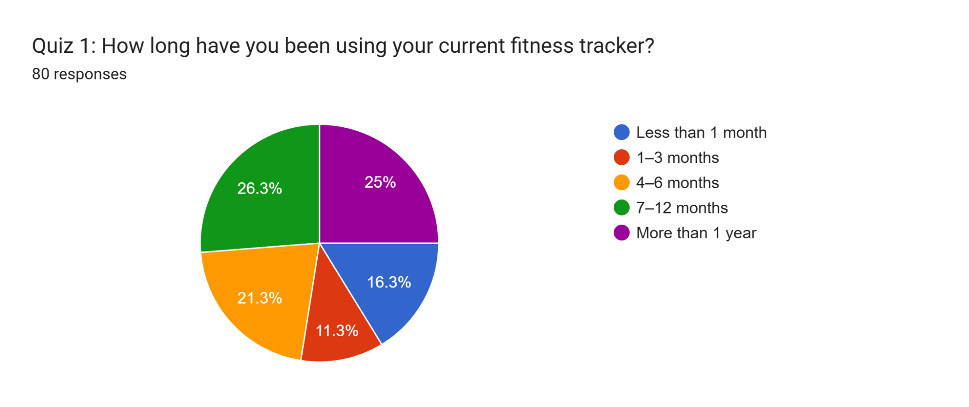
In percentage terms, 26.3% of respondents reported using their devices for 7–12 months, while 25% indicated more than one year of use. A smaller proportion had adopted trackers more recently, with 16.3% using them for less than one month and 11.3% for 1–3 months. The 21.3% in the 4–6 month range highlights a balanced mix of both newer and longer-term users in the sample.
Frequency of Device Replacement
The data showed that participants replace or upgrade their devices at moderate intervals, with a mean of 2.9, a mode of 3.0, and a standard deviation of 1.2. These values suggest that most respondents fall around the "occasionally" category, typically upgrading every two years, with few extreme cases of either never upgrading or replacing devices very frequently.
Figure 2: Frequency of Device Replacement
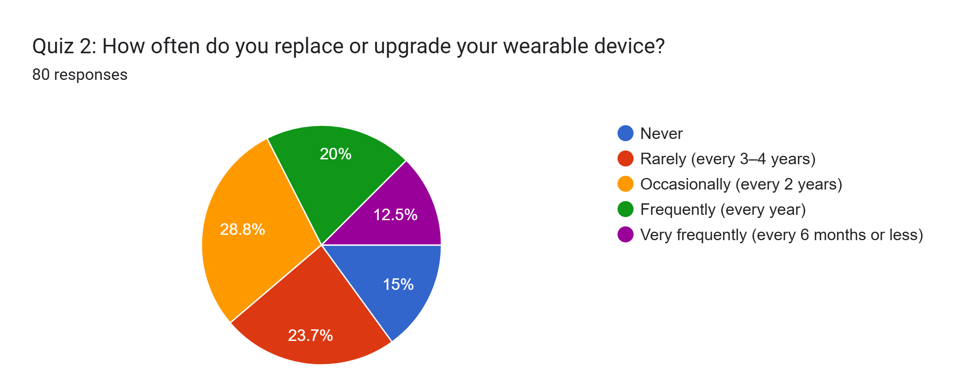
In terms of percentages, 28.8% of participants reported upgrading occasionally (every two years), followed by 23.7% rarely upgrading (every 3–4 years). Meanwhile, 20% upgraded annually, and 12.5% replaced their devices very frequently within six months or less. Only 15% never upgraded, showing that device replacement is relatively common but not overly frequent among respondents.
Factors Influencing Tracker Choice
Analysis of influencing factors showed a mean of 3.6, mode of 3.0, and a standard deviation of 1.5, suggesting a wide range of preferences. Features offered emerged as the dominant driver, while brand reputation and peer or online input also carried weight. Price and design, although relevant, ranked lower in influence compared to functional considerations.
Figure 3: Factors Influencing Tracker Choice
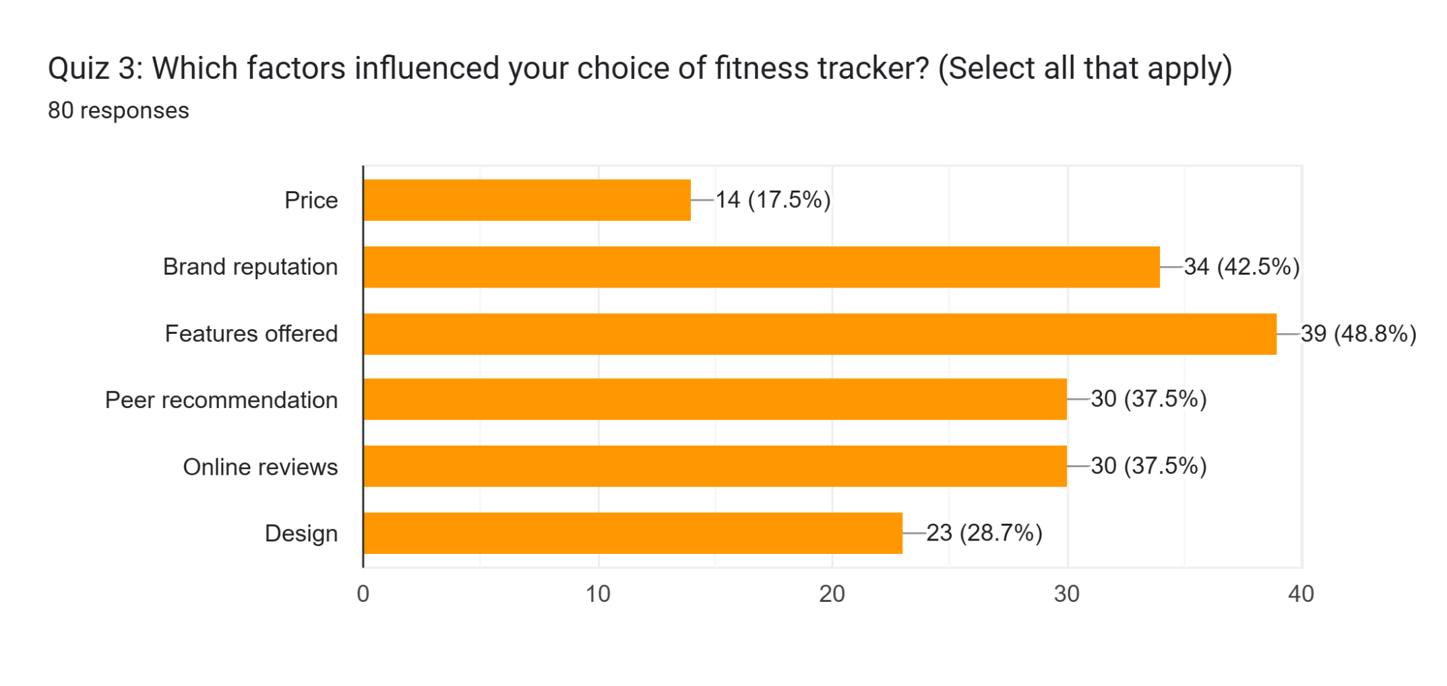
From a percentage perspective, 48.8% of respondents selected features offered as a key factor, making it the leading choice. Brand reputation influenced 42.5%, while peer recommendations and online reviews each influenced 37.5%. Design considerations were important for 28.7%, whereas price mattered to only 17.5%, indicating that functionality and trust outweigh cost concerns in tracker adoption.
Sharing Fitness Data with Others
Findings indicated a mean of 3.4, a mode of 4.0, and a standard deviation of 1.0. This suggests that respondents tended to share data often, with relatively low variability in responses. The central tendency points toward a culture of openness in sharing health-related information, likely driven by social or motivational factors.
Figure 4: Sharing Fitness Data with Others
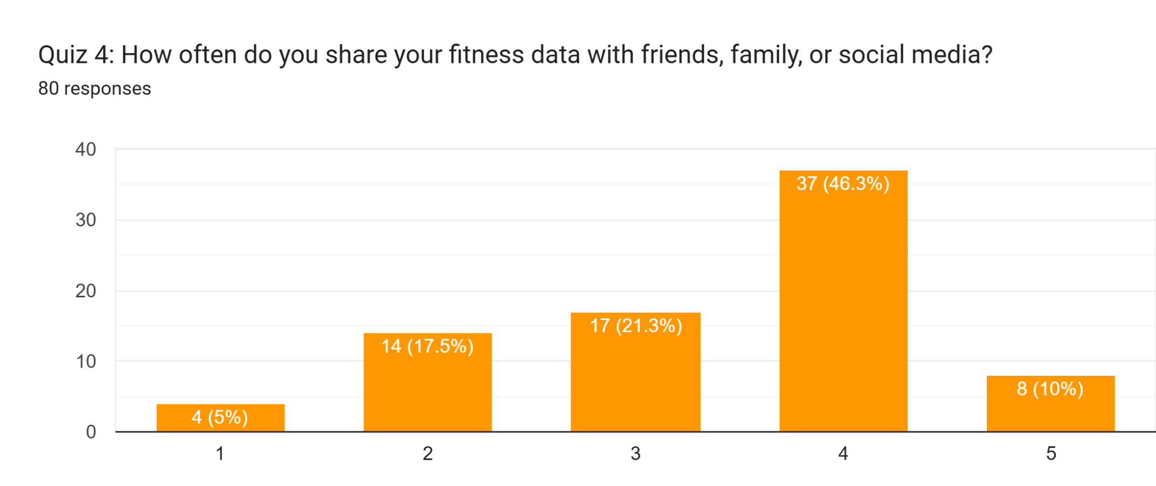
Percentage results confirmed this trend, with 46.3% of participants sharing often and 10% always sharing. Conversely, 21.3% sometimes shared, while 17.5% shared rarely. Only 5% never shared fitness data, underscoring the generally high level of social integration linked with wearable usage in the studied population.
Continuation of Fitness Tracker Use
The analysis recorded a mean of 4.0, a mode of 5.0, and a standard deviation of 1.2. This distribution suggests a strong inclination to continue using trackers, with the highest concentration leaning toward "very likely." The relatively small spread reflects a consistent trend of commitment among participants.
Figure 5: Continuation of Fitness Tracker Use
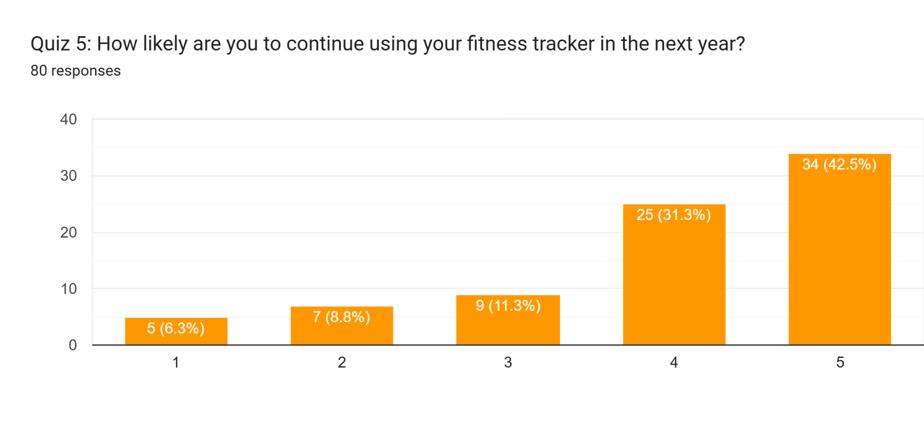
In percentage terms, 42.5% indicated they were very likely to continue, and 31.3% stated they were likely to maintain usage. Neutral responses accounted for 11.3%, while smaller shares expressed reluctance, with 8.8% unlikely and 6.3% very unlikely. Overall, more than 70% demonstrated strong intentions for continued engagement.
Income and Tracker Affordability
The results showed a mean of 3.4, a mode of 4.0, and a standard deviation of 1.3. These values indicate that income was moderately enabling, with respondents more likely to feel that financial resources supported rather than restricted tracker use. However, variation remained noticeable, reflecting differences in economic situations.
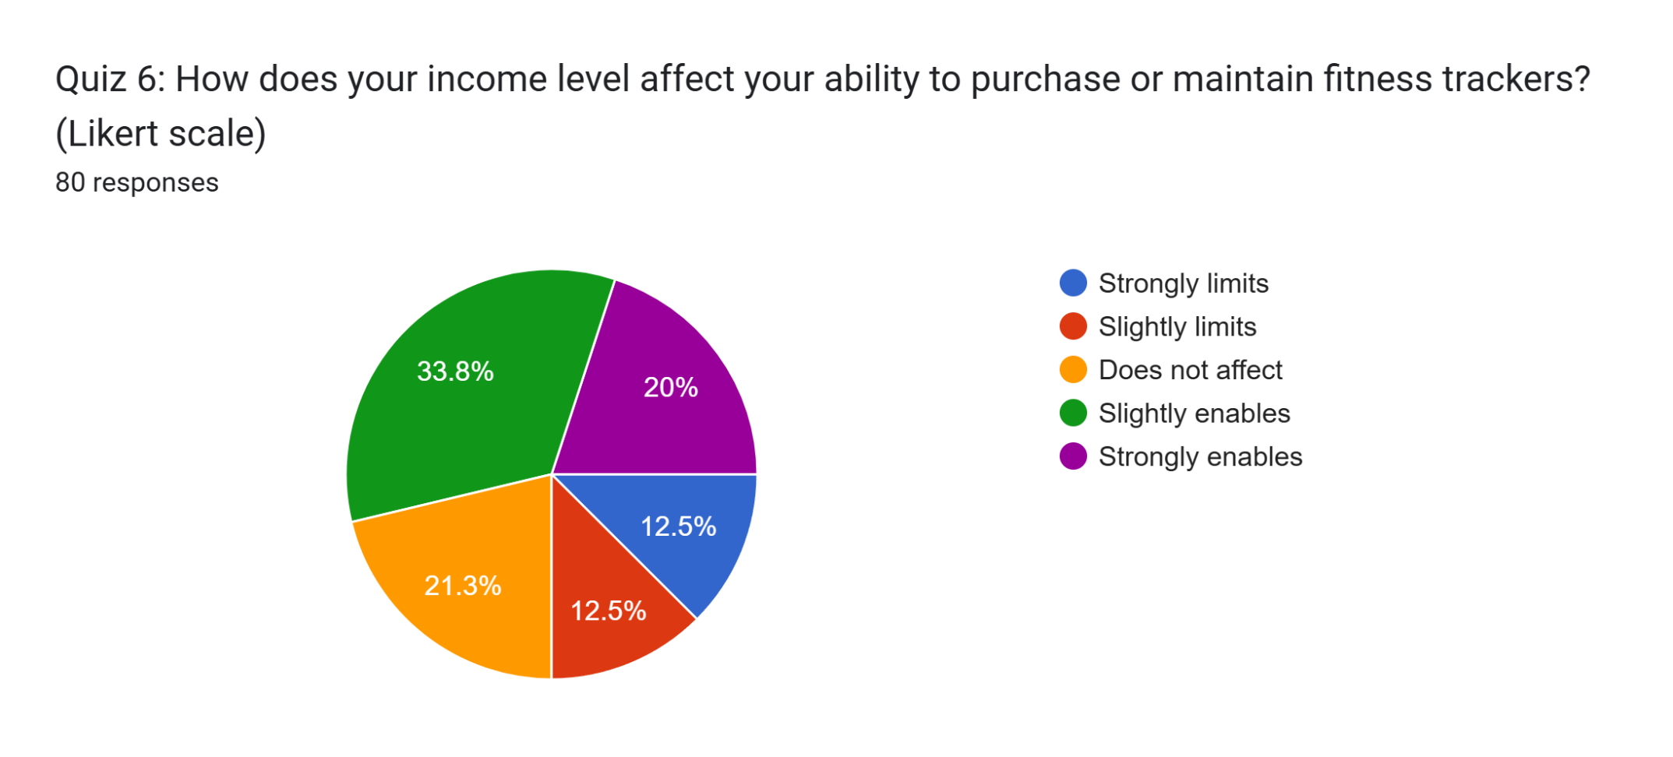
Percentage distribution showed that 33.8% felt their income slightly enabled tracker use, while 20% reported it strongly enabled them. Conversely, 21.3% stated income did not affect their usage, while 12.5% each reported that it strongly or slightly limited them. This suggests that while affordability is not a major barrier, it still impacts a minority of users.
Challenges in Tracker Usage
The descriptive statistics recorded a mean of 3.0, a mode of 2.0, and a standard deviation of 1.2, indicating that challenges were present but varied across participants. The relatively low mean suggests that while some challenges exist, they were not overwhelming, with battery life and motivation emerging as notable issues.
Figure 6: Challenges in Tracker Usage
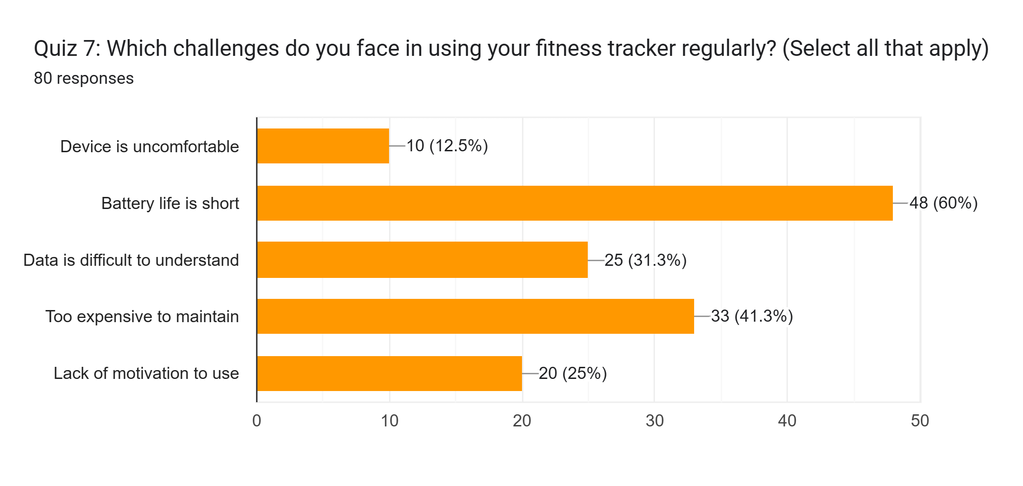
From a percentage perspective, the most cited challenges included short battery life and tracking wearable devices being too expensive. Difficulties such as high costs and discomfort also appeared, though less frequently. Overall, the data indicated that technical limitations and personal adherence were the main barriers, while affordability and design played secondary roles.
Support from Friends and Family
The analysis reported a mean of 3.6, a mode of 4.0, and a standard deviation of 1.1, suggesting that respondents generally experienced a high level of support. The central tendency was toward "very supportive," with limited dispersion, highlighting consistent encouragement from social networks.
Figure 7: Support from Friends and Family
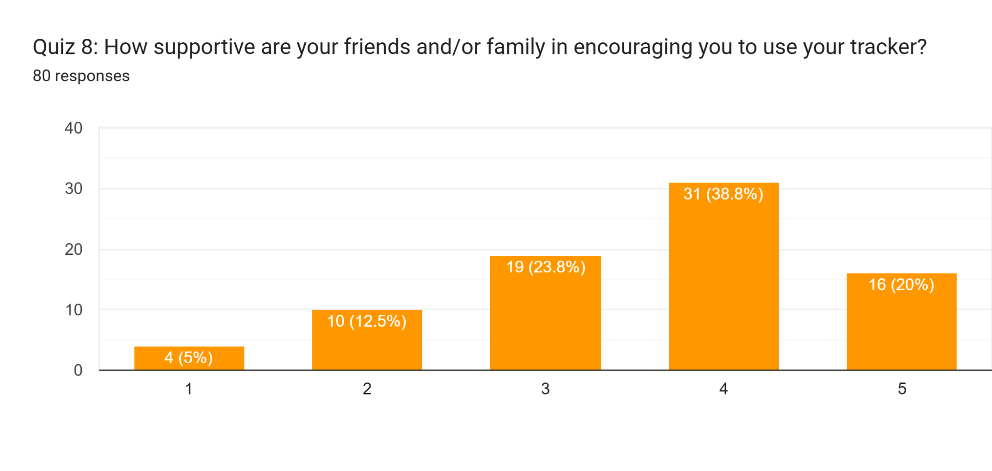
Percentages supported this interpretation, as 38.8% reported friends and family were very supportive, and 20% found them extremely supportive. A further 23.8% experienced moderate support, while smaller shares of 12.5% and 5% indicated only slight or no support, respectively. This demonstrates that social encouragement is a significant positive factor in tracker engagement.
Tracker Fit into Lifestyle
The results showed that the fitness tracker integrated moderately well into participants’ lifestyles, with a mean score of 3.6, a mode of 4.0, and a standard deviation of 1.2. These values suggest that most respondents perceived the tracker as fitting positively within the balance of work, family, and social activities, though experiences varied across the sample.
Figure 8: Tracker Fit into Lifestyle
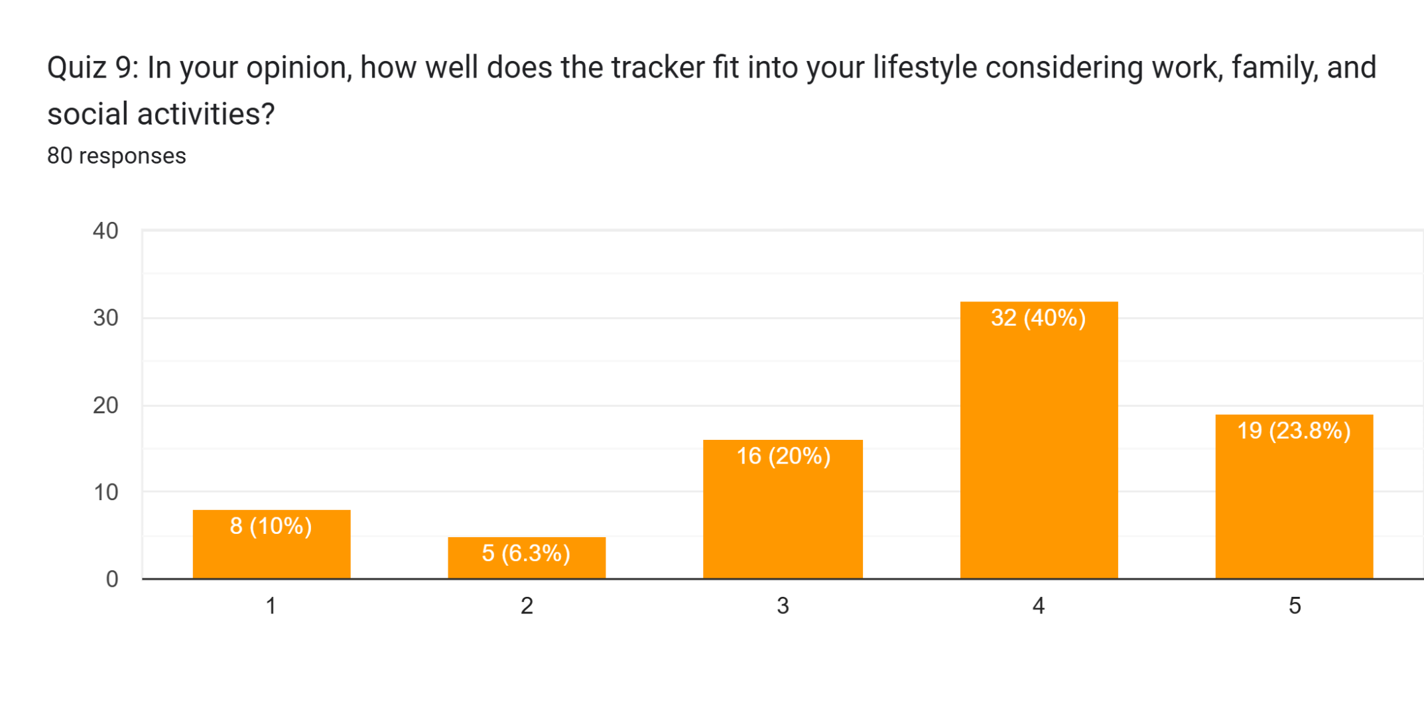
From a percentage perspective, 40% indicated the tracker fit “well,” while 23.8% reported it fit “very well.” Neutral responses accounted for 20%, whereas 6.3% and 10% felt it fit poorly or very poorly, respectively. This distribution highlights that the majority found the device adaptable, but a minority experienced challenges in lifestyle integration.
Frequency of Physical Activity
The analysis indicated a mean of 3.2, a mode of 3.0, and a standard deviation of 1.0. These findings reveal that participants generally engaged in moderate physical activity three to four times per week, reflecting a balanced yet non-daily exercise pattern. The narrow spread suggests relatively consistent activity habits across respondents.
Figure 9: Frequency of Physical Activity
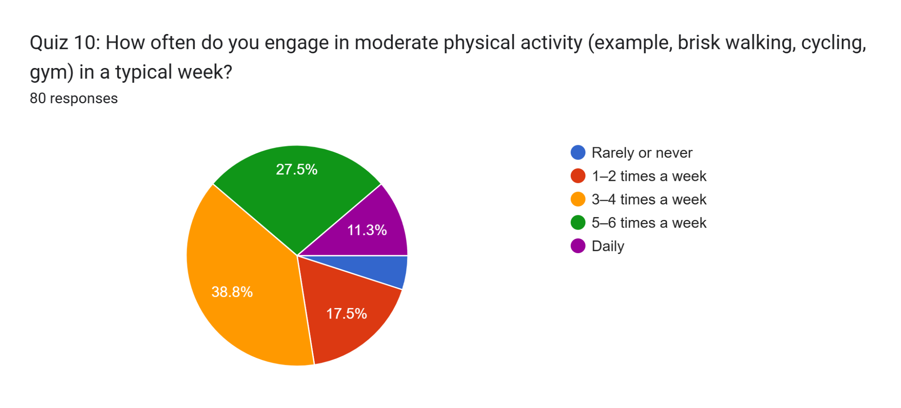
In percentage terms, 38.8% reported engaging in activity 3–4 times weekly, while 27.5% exercised 5–6 times. Only 11.3% engaged daily, and 17.5% reported just 1–2 times per week. A small fraction (4.9%) rarely or never participated, suggesting most respondents incorporated regular physical activity into their routines.
Change in Physical Activity
The findings produced a mean of 3.5, a mode of 4.0, and a standard deviation of 1.3. This indicates that most participants reported increased activity since using their trackers, with a tilt toward slight improvements rather than drastic changes. However, the higher standard deviation shows that experiences varied considerably.
Figure 10: Change in Physical Activity
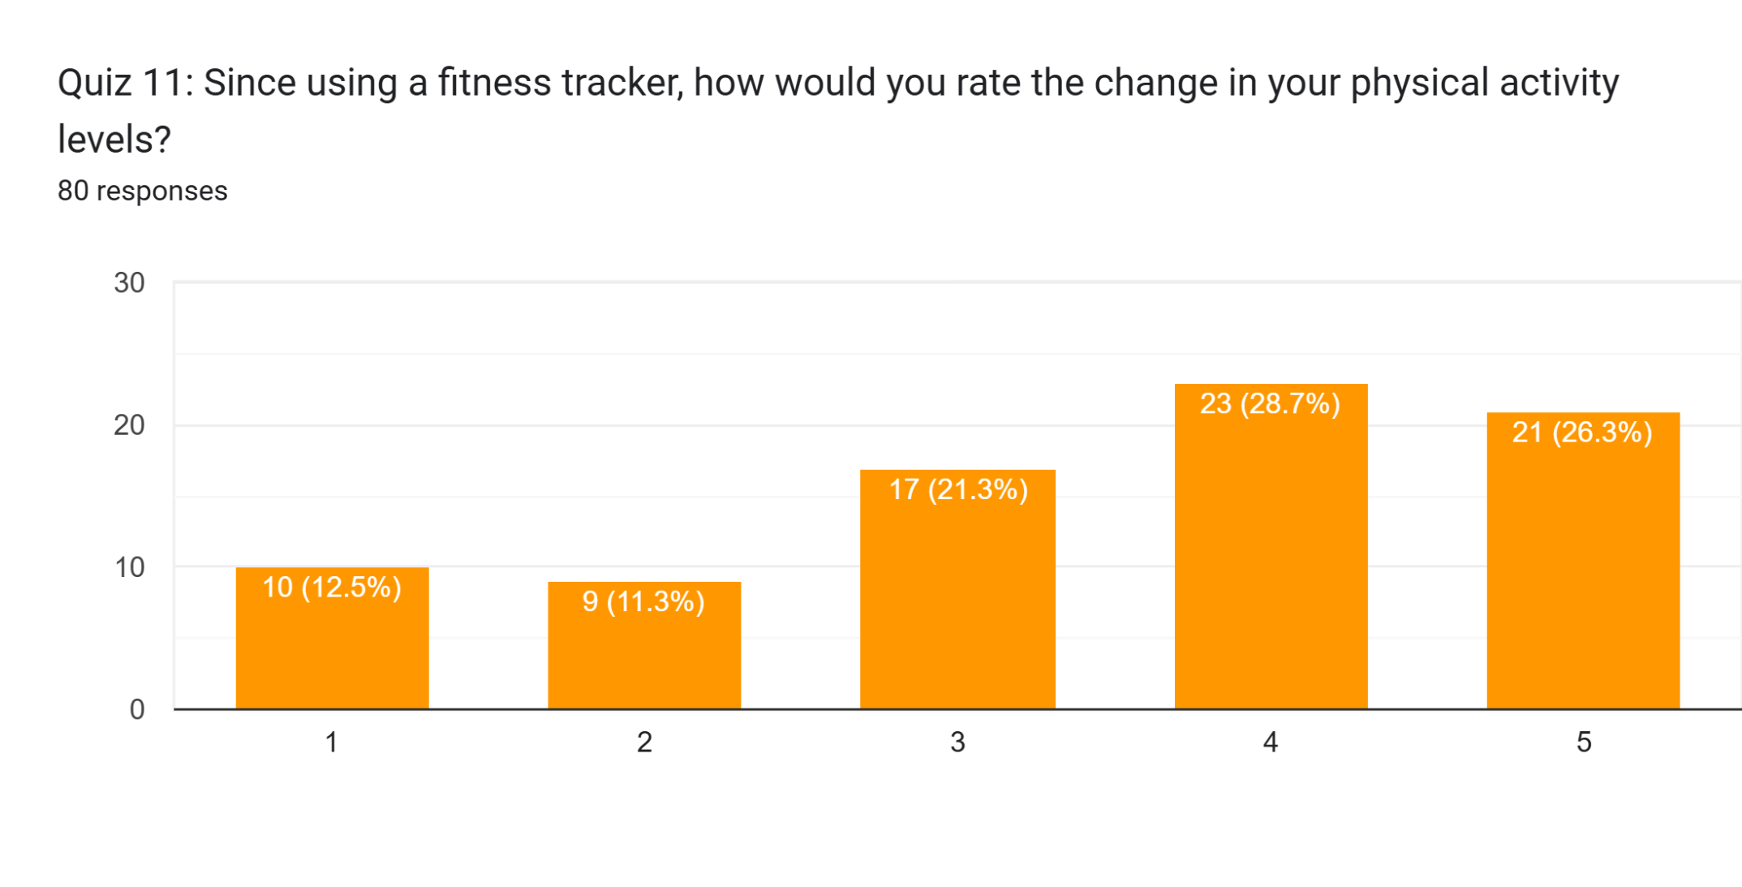
Percentage results revealed that 28.7% experienced slightly increased activity, while 26.3% reported strongly increased levels. Conversely, 21.3% experienced no change, 11.3% reported slightly decreased activity, and 12.5% strongly decreased. This suggests that while many respondents benefited, a notable minority reported reduced activity despite tracker use.
Change in Sedentary Behavior
Analysis yielded a mean of 3.2, a mode of 4.0, and a standard deviation of 1.2. These results indicate that participants, on average, experienced a slight decrease in daily sedentary hours, though responses were dispersed across categories. The findings reflect modest effectiveness of trackers in encouraging reduced sitting time.
Figure 11: Change in Sedentary Behavior
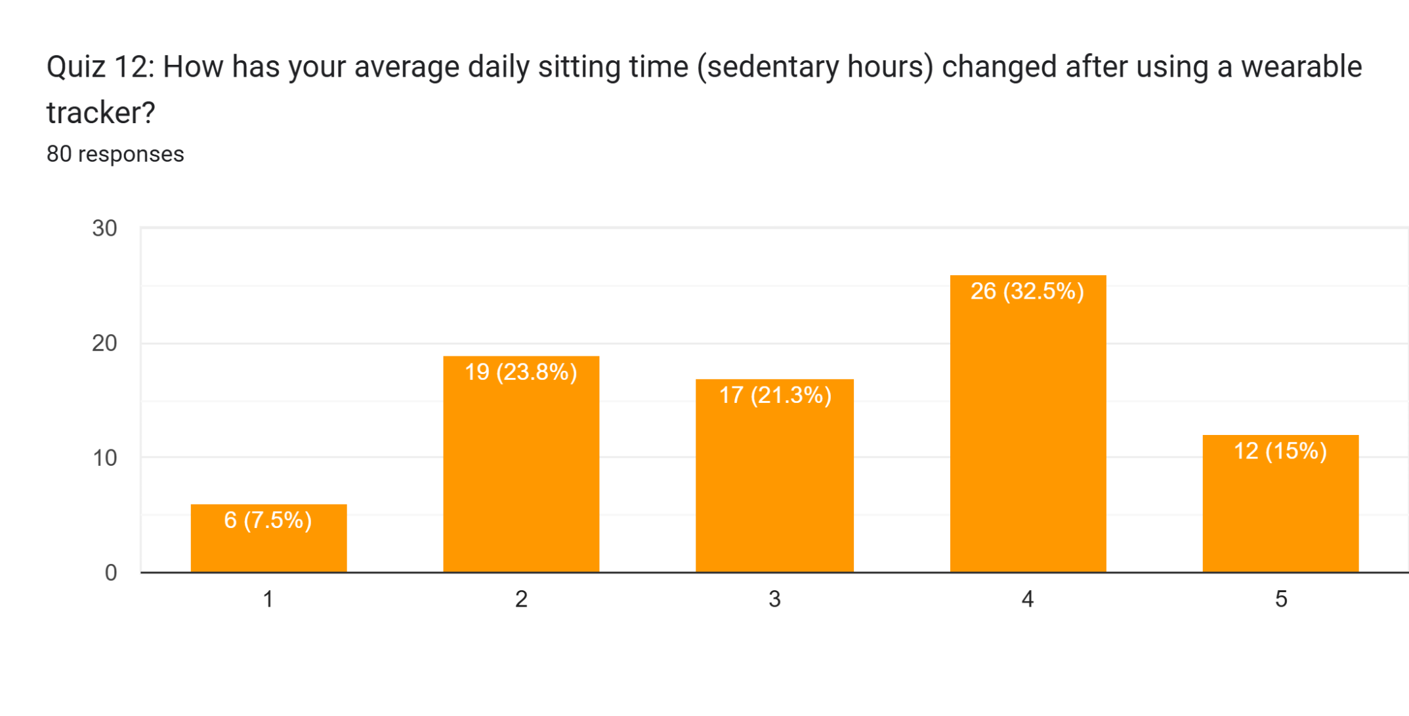
Percentages showed that 32.5% reported slightly decreased sitting hours, while 15% strongly decreased them. In contrast, 21.3% observed no change, and 23.8% reported slight increases, with 7.5% experiencing strong increases. This balance highlights mixed outcomes, where sedentary time decreased for many but increased for a smaller segment.
Average Hours of Sleep
The analysis revealed a mean of 3.4, a mode of 4.0, and a standard deviation of 1.0. This indicates that participants typically reported sleeping between 7–8 hours per night, which aligns with recommended guidelines for adults. The relatively low standard deviation shows that sleep duration was fairly consistent across the sample.
Figure 12: Average Hours of Sleep
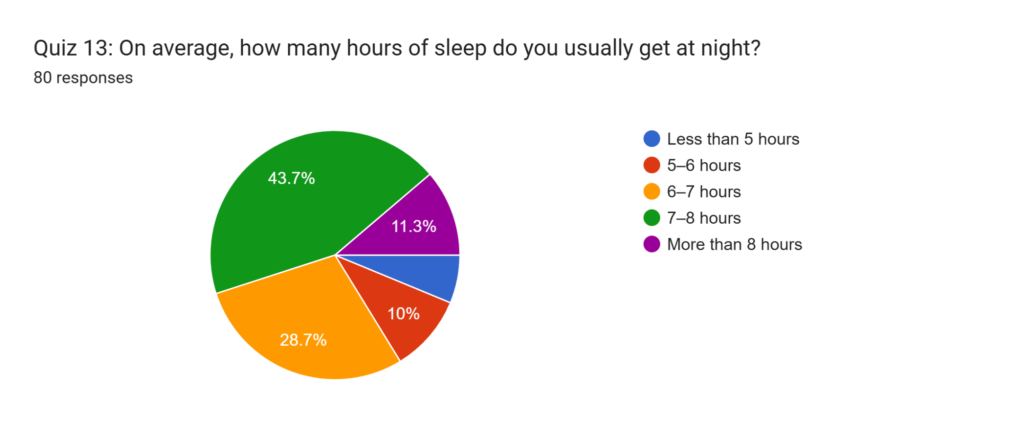
In terms of percentages, 43.7% reported sleeping 7–8 hours, while 28.7% had 6–7 hours. More than 8 hours of sleep was noted by 11.3%, whereas 10% slept only 5–6 hours and 6.3% less than 5 hours. Overall, most participants reported sufficient nightly sleep, with few experiencing inadequate rest.
Change in Sleep Quality
The findings showed a mean of 3.7, a mode of 4.0, and a standard deviation of 1.1. This suggests that participants generally experienced improved sleep quality after using trackers, leaning toward slight improvements rather than extreme changes. Variability in responses remained moderate, reflecting different individual experiences.
Figure 13: Change in Sleep Quality
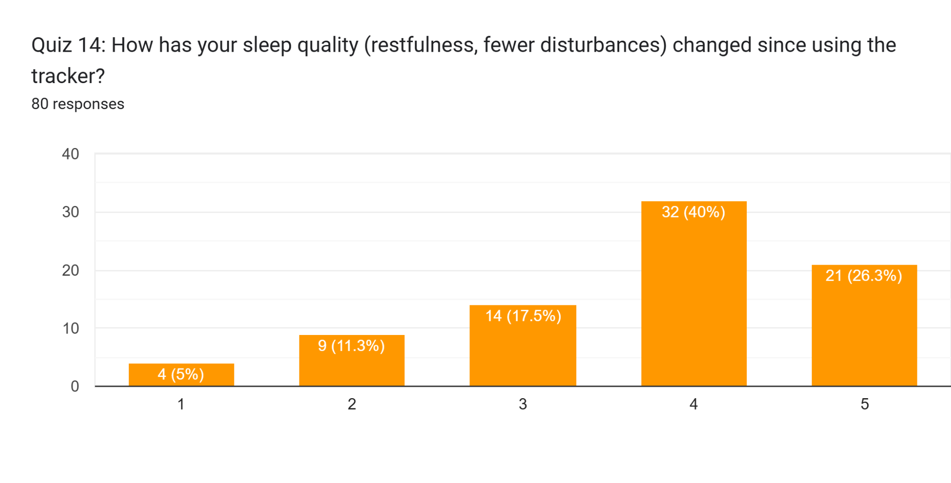
Percentage results indicated that 40% reported slightly better sleep, and 26.3% noted much better quality. Meanwhile, 17.5% experienced no change, 11.3% reported slight deterioration, and 5% reported much worse sleep. Overall, improvements outnumbered declines, suggesting a generally positive effect on sleep quality.
Adjusted Lifestyle Habits
The analysis produced a mean of 2.8, a mode of 2.0, and a standard deviation of 1.0, showing that respondents made selective adjustments to their habits. The results suggest that while several lifestyle behaviors were influenced by trackers, the degree of adjustment varied across individuals.
Figure 14: Adjusted Lifestyle Habits
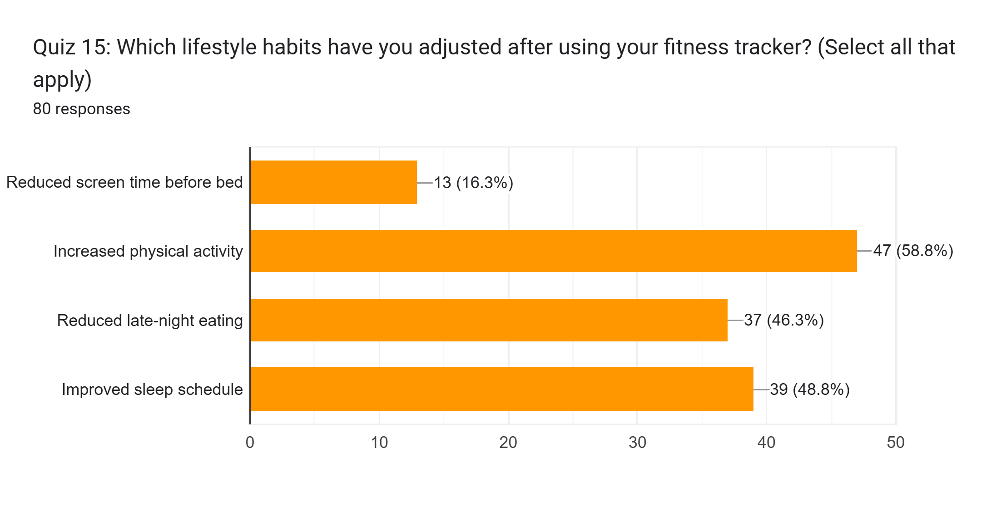
Percentage findings showed that 58.8% increased physical activity, while 48.8% improved sleep schedules. Reduced late-night eating was reported by 46.3%, whereas only 16.3% reduced screen time before bed. These outcomes suggest that fitness trackers had the greatest impact on activity and sleep-related behaviors, with weaker influence on screen habits.
Frequency of Checking Data
The descriptive analysis yielded a mean of 2.7, a mode of 3.0, and a standard deviation of 1.0. This indicates that participants typically checked their tracker data between 2–5 times daily, reflecting regular engagement. The spread suggests moderate variation, with some checking less frequently and others more intensively.
Figure 15: Frequency of Checking Data
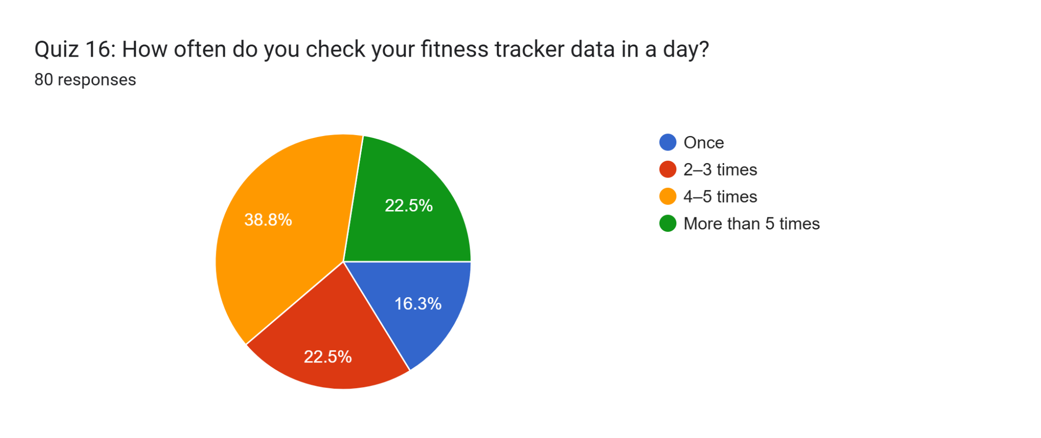
Percentage analysis confirmed this pattern, as 38.8% checked their data 4–5 times per day, while 22.5% checked more than five times and another 22.5% checked 2–3 times. A smaller 16.3% checked only once per day. This shows that most respondents actively monitored their progress multiple times daily.
Motivation from Tracker Data
The analysis showed a mean score of 3.6, a mode of 4.0, and a standard deviation of 1.2. This indicates that the majority of participants felt moderately to highly motivated when viewing their fitness tracker data, with responses clustering around “very motivated.” The findings suggest that the visual feedback from trackers played a significant role in encouraging exercise.
Figure 16: Motivation from Tracker Data
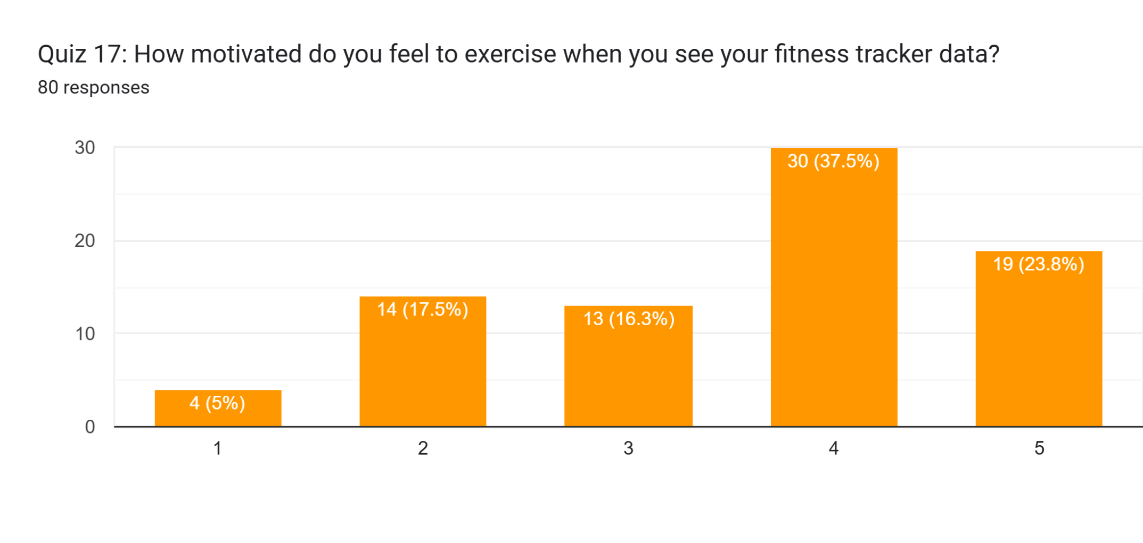
In percentage terms, 37.5% of participants reported being very motivated, while 23.8% felt extremely motivated. Moderate motivation was noted by 16.3%, whereas only 7.5% were slightly motivated and 5% not motivated at all. Overall, more than 60% displayed strong motivational responses when interacting with their devices.
Consistency in Exercise Habits
The results revealed a mean of 3.5, a mode of 3.0, and a standard deviation of 1.1. This demonstrates that participants experienced a moderate to high level of habit formation due to tracker use. The majority leaned toward moderate or strong habit consistency, suggesting trackers were effective tools in reinforcing exercise routines.
Figure 17: Consistency in Exercise Habits
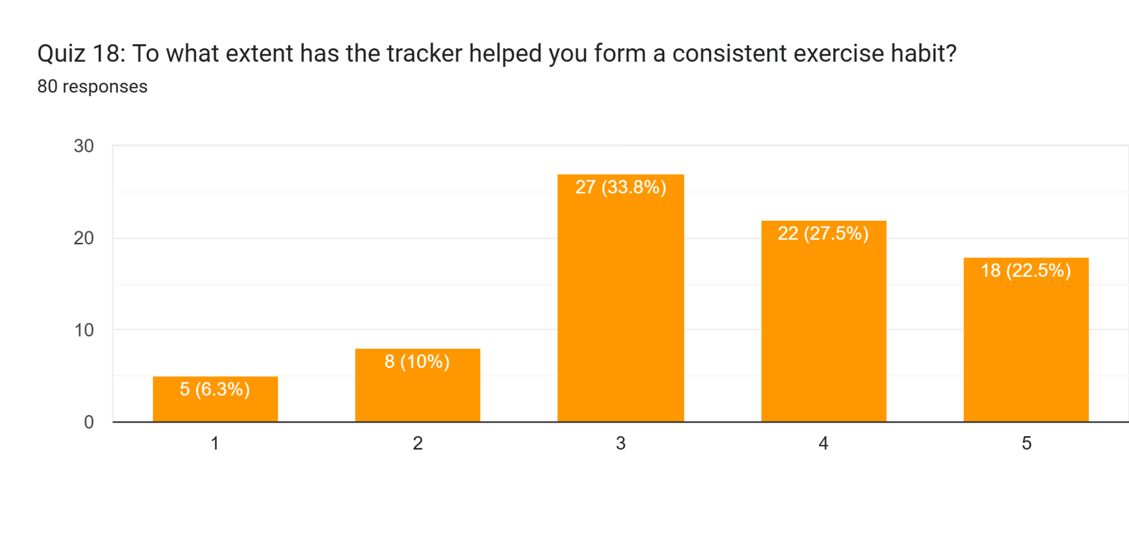
Percentage distribution showed that 33.8% reported moderate habit formation, 27.5% very much, and 22.5% completely formed consistent exercise habits. On the other hand, 10% reported only slight improvement, and 6.3% indicated no effect. Thus, most respondents confirmed the positive role of trackers in developing structured routines.
Reaching Daily Activity Goals
The findings produced a mean of 3.5, a mode of 4.0, and a standard deviation of 1.1. These values indicate that participants frequently achieved their daily activity goals, with a central tendency toward “often.” The consistency highlights strong engagement with fitness targets, though a small minority struggled to reach them.
Figure 18: Reaching Daily Activity Goals
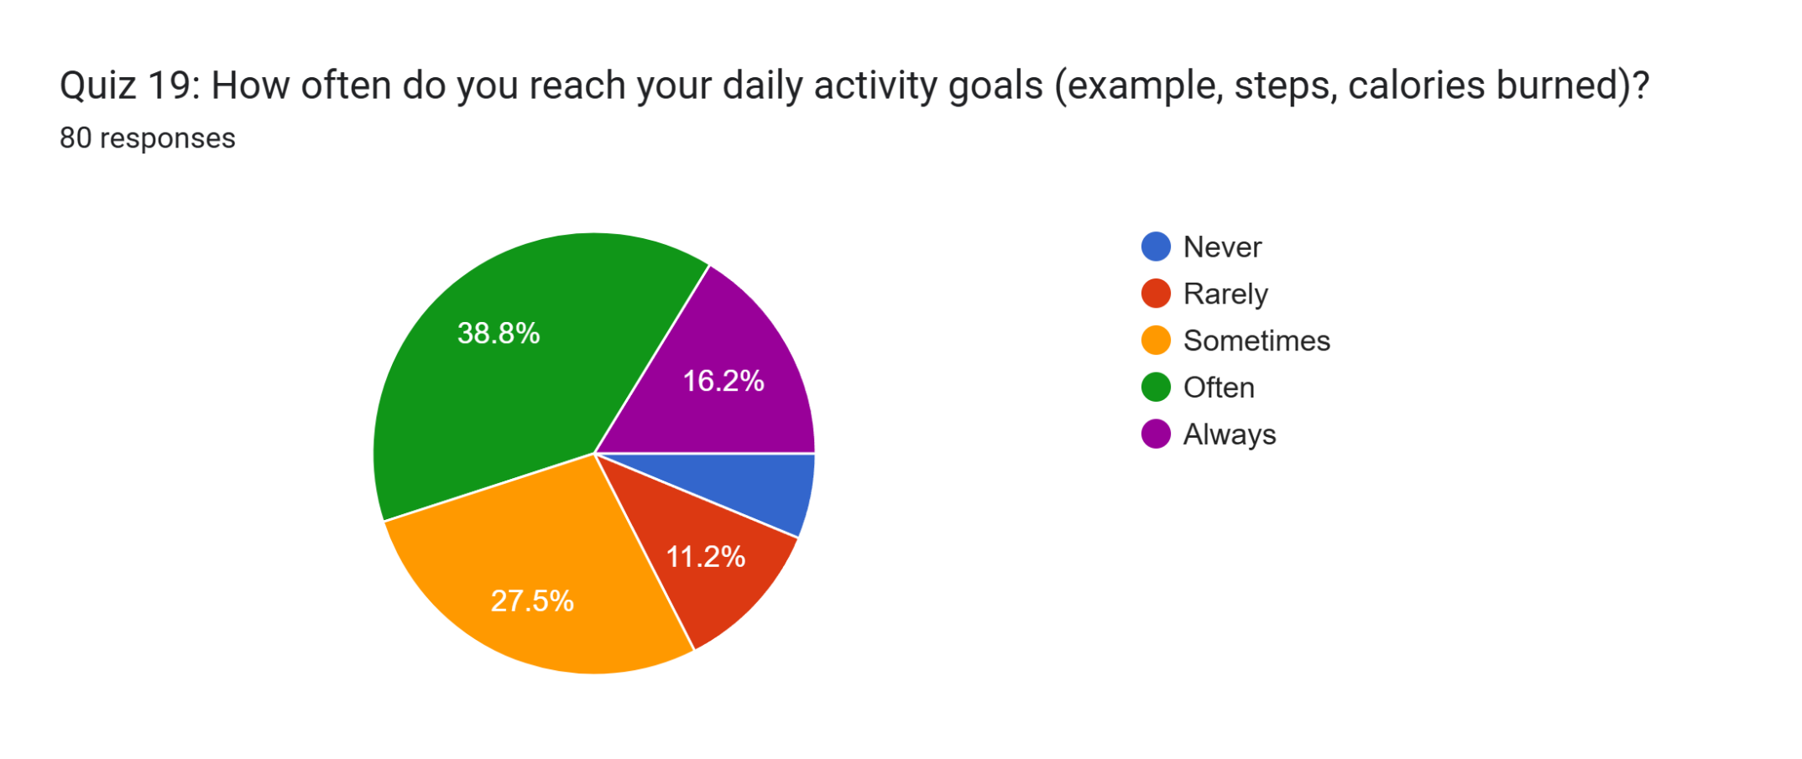
From the percentage breakdown, 38.8% achieved their goals often, while 16.2% always reached them. Another 27.5% sometimes met goals, whereas 11.2% rarely and 6.3% never succeeded. The data demonstrates that nearly two-thirds of participants consistently met activity targets, showing positive alignment with daily fitness behaviors.
Helpfulness of Tracker Reminders
The descriptive statistics indicated a mean of 3.7, a mode of 5.0, and a standard deviation of 1.2. This distribution shows that tracker reminders were largely regarded as useful, with responses clustering toward “very helpful” and “extremely helpful.” The findings underscore the supportive role of reminders in maintaining healthy behaviors.
Figure 19: Helpfulness of Tracker Reminders
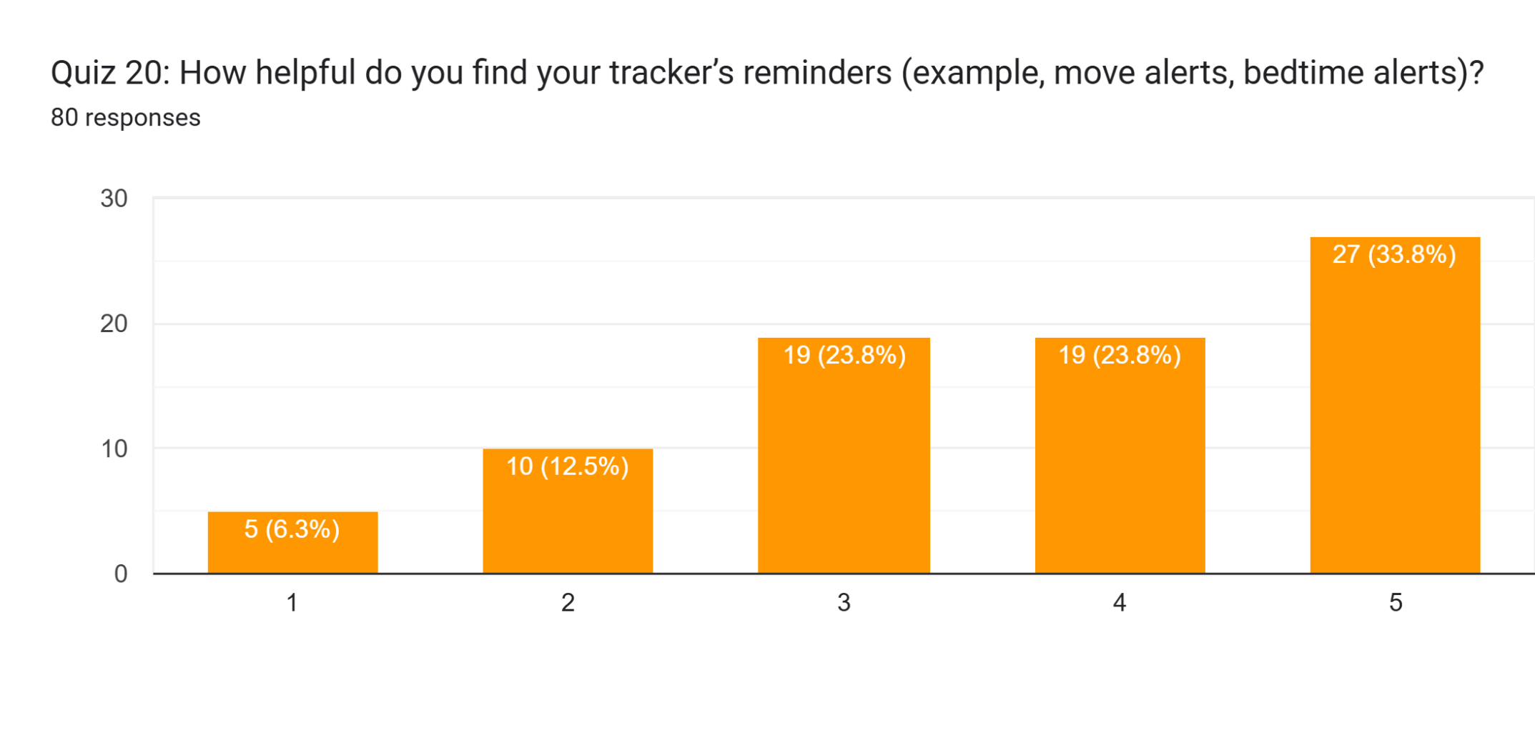
Percentage results reinforced this, as 33.8% of participants found reminders extremely helpful and 23.8% very helpful. Another 23.8% rated them moderately helpful, while 12.5% and 6.3% felt they were only slightly helpful or not at all, respectively. Overall, over half of participants rated reminders at the higher usefulness levels.
Most Used Tracker Features
Analysis revealed a mean of 3.6, a mode of 4.0, and a standard deviation of 1.6, suggesting wide variability in preferred tracker functions. The data points to calorie monitoring and heart rate measurement as the most heavily used, while traditional step counting was less dominant compared to more advanced features.
Figure 20: Most Used Tracker Features
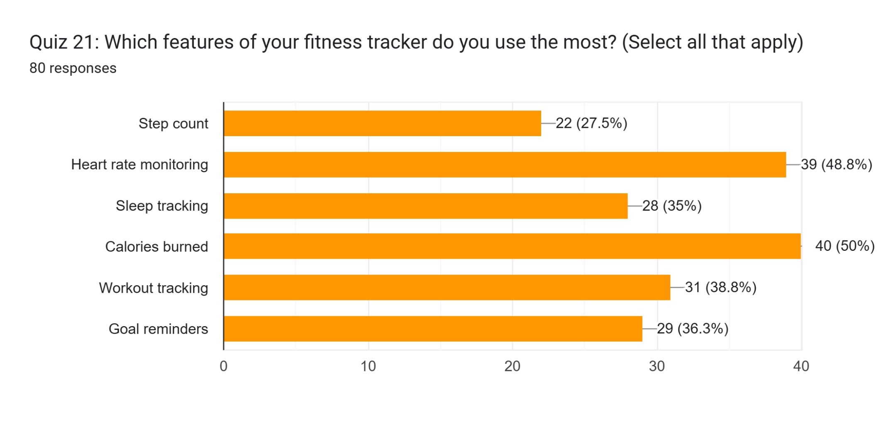
In percentage terms, 50% of respondents reported using calorie tracking most, closely followed by 48.8% for heart rate monitoring. Workout tracking was used by 38.8%, goal reminders by 36.3%, and sleep tracking by 35%. Step count was the least used at 27.5%, showing a shift toward holistic health monitoring beyond step-based activity.
Feelings When Goals Not Met
The results showed a mean of 2.8, a mode of 2.0, and a standard deviation of 1.4. This indicates a tendency toward discouragement when daily goals were not achieved, though responses varied widely. The findings highlight a mix of negative emotions and slight encouragement among participants.
Figure 21: Feelings When Goals Not Met
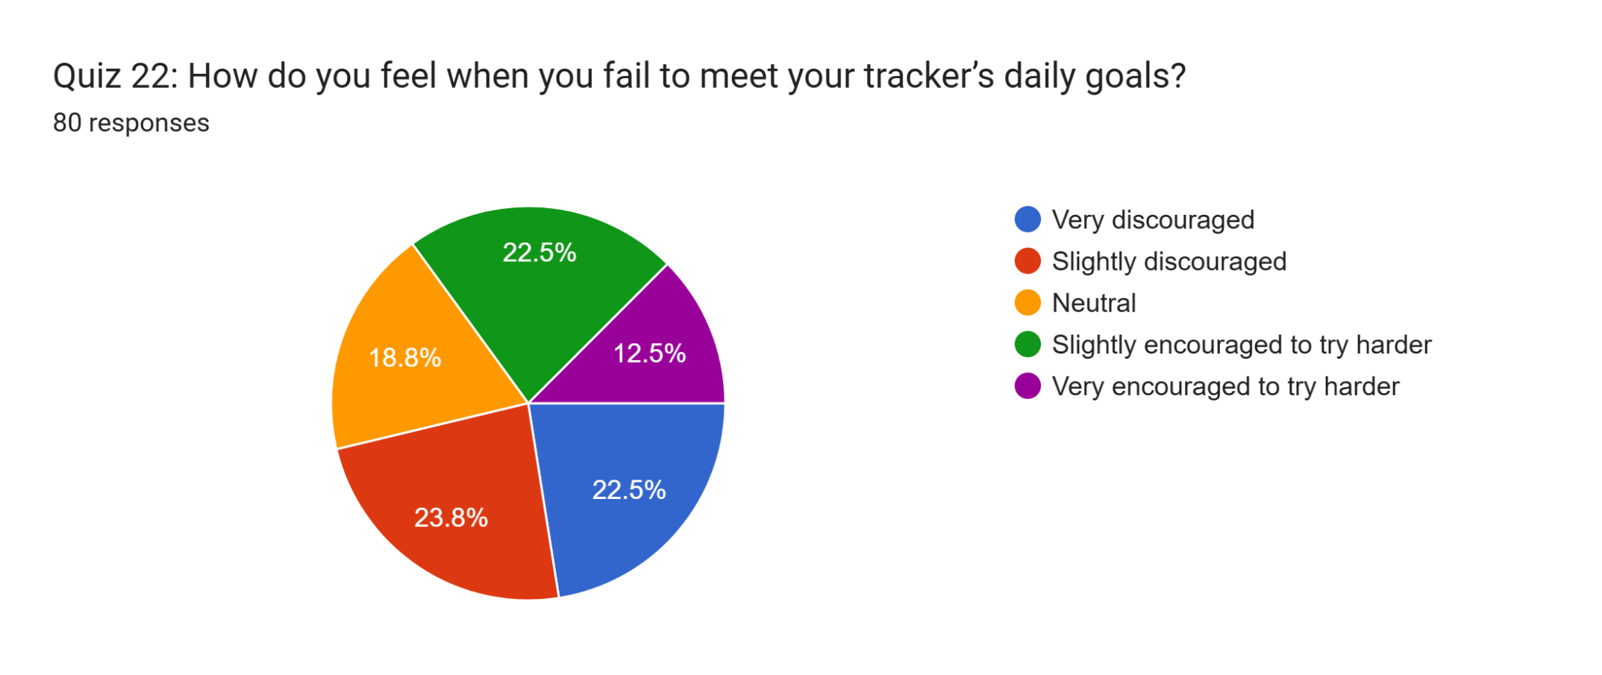
From the percentages, 23.8% felt slightly discouraged, and 22.5% were very discouraged. Conversely, 22.5% reported being slightly encouraged to try harder, while 12.5% felt very encouraged. Neutral feelings were reported by 18.8%. This distribution demonstrates that while many experienced discouragement, a significant portion responded with resilience and motivation.
Overall Satisfaction with Tracker
The descriptive analysis revealed a mean of 3.8, a mode of 4.0, and a standard deviation of 1.1. This indicates that respondents were generally satisfied with their trackers, with ratings clustering between “satisfied” and “very satisfied.” The narrow spread suggests relatively consistent positive experiences.
Figure 22: Overall Satisfaction with Tracker
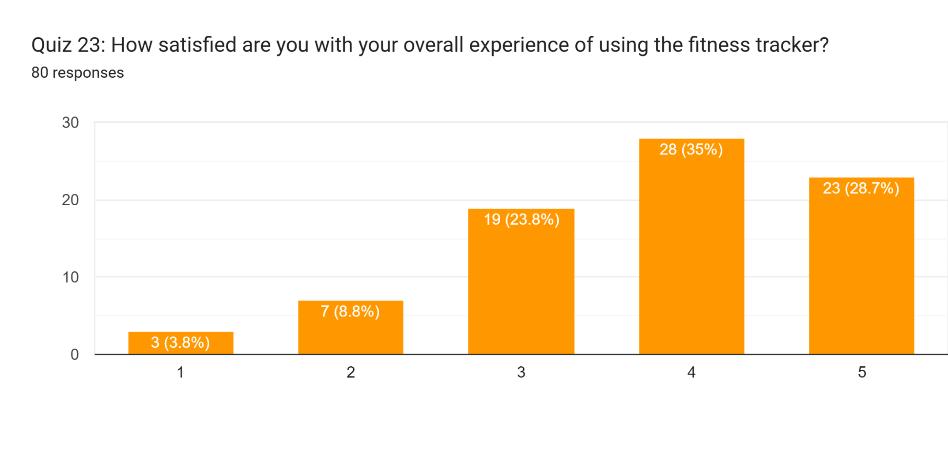
Percentages confirmed this pattern, as 35% reported being satisfied and 28.7% very satisfied. Neutral opinions were given by 23.8%, while only 8.8% were dissatisfied and 3.8% very dissatisfied. The majority of respondents thus expressed favorable attitudes toward their overall tracker experience.
Behavioral Changes Due to Tracker
The results produced a mean of 3.0, a mode of 4.0, and a standard deviation of 1.4. This suggests that behavioral adjustments occurred moderately, with some habits changing more than others. The most frequent shifts related to daily movement and sleep, while hydration and screen-time reduction were less common.
Figure 23: Behavioral Changes Due to Tracker
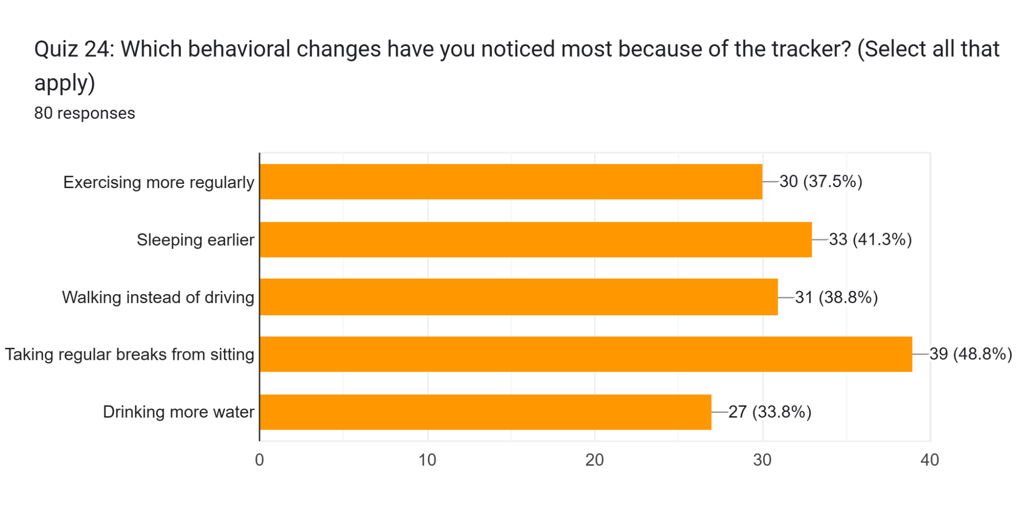
Percentage analysis showed that 48.8% reported taking regular breaks from sitting, 41.3% slept earlier, and 38.8% walked instead of driving. Exercising more regularly was observed by 37.5%, while 33.8% increased water intake. These findings indicate that trackers contributed to both activity-related and lifestyle-oriented behavioral changes.

Correlational analysis
Physical Activity, Sleep, and Sedentary Time
The correlation analysis revealed strong associations between activity-related variables and sedentary time. Activity Change was highly correlated with Sitting Time (r = 0.8) and Exercise Motivation (r = 0.8), suggesting that participants who reported changes in physical activity were also more likely to adjust sedentary behaviors and remain motivated. Similarly, Sleep Quality was strongly associated with Future Use (r = 0.8) and Lifestyle Fit (r = 0.7), indicating that better rest quality coincided with greater integration of trackers into daily routines. Sleep Hours showed consistent positive correlations with Data Sharing (r = 0.6), Family Support (r = 0.6), and Sitting Time (r = 0.6), reflecting that longer sleep duration aligned with supportive environmental factors.

Motivation, Habits, and Behavioral Mechanisms
Behavioral constructs showed consistently strong correlations with lifestyle adjustments. Exercise Motivation was highly related to Habit Formation (r = 0.8) and Overall Satisfaction (r = 0.8), demonstrating that motivation was intertwined with developing sustainable exercise habits and long-term device satisfaction. Habit Formation also correlated strongly with Lifestyle Fit (r = 0.8) and Reminder Helpfulness (r = 0.7), suggesting reminders played a role in embedding behavioral changes. Check Frequency, while moderately correlated with other indicators, showed the strongest link with Income Impact (r = 0.6), highlighting that device engagement varied with financial considerations.
Socioeconomic and Demographic Moderators
Correlations underscored the moderating role of income and family support. Income Impact was positively correlated with Family Support (r = 0.7), Exercise Motivation (r = 0.7), and Overall Satisfaction (r = 0.6), indicating that higher-income participants with supportive environments reported stronger lifestyle integration and motivation. Family Support, in turn, was strongly related to Lifestyle Fit (r = 0.7) and Sleep Quality (r = 0.7), suggesting that social environments reinforced the sustained use of trackers. Additionally, Future Use was significantly correlated with Sleep Quality (r = 0.8) and Lifestyle Fit (r = 0.7), reinforcing the role of socioeconomic and contextual factors in continued adoption.
Goal Setting and Self-Monitoring
Goal-related variables displayed strong internal associations. Reminder Helpfulness correlated highly with Goal Achievement (r = 0.8) and Lifestyle Fit (r = 0.8), indicating that system-driven nudges facilitated goal consistency. Conversely, Goal Failure showed minimal correlation with Goal Achievement (r = 0.0) and Reminder Helpfulness (r = 0.0), suggesting that failing to meet targets operated independently of other motivational factors. Overall Satisfaction correlated strongly with Habit Formation (r = 0.8), Exercise Motivation (r = 0.8), and Reminder Helpfulness (r = 0.7), highlighting satisfaction as a central outcome tied to both behavioral mechanisms and self-monitoring processes.

ANALYSIS

Key Inferences from Findings
The descriptive and percentage analyses revealed that wearable fitness trackers had a measurable influence on exercise motivation. A mean score of 3.6 and a mode of 4.0 for motivation to exercise suggested that most participants felt “very motivated” when reviewing their data, while nearly 62% reported being either very or extremely motivated. This indicates that the visual feedback and self-monitoring elements of the devices served as effective motivational tools for the majority of users.
Consistency in exercise habits was another strong outcome. With a mean score of 3.5 and 33.8% of participants reporting “moderate” consistency and a further 50% reporting “very much” or “completely,” the trackers appeared to play a significant role in habit formation. The correlation results further supported this, with strong links between habit formation, lifestyle fit (r = 0.8), and reminder helpfulness (r = 0.7). This suggests that the device functions not only supported short-term motivation but also reinforced long-term behavioral change.
Activity goal achievement patterns highlighted an encouraging trend. The majority (38.8%) reported “often” reaching their daily activity goals, while 16.2% reported “always.” The descriptive mean of 3.5 reinforced this tendency towards frequent goal achievement. This outcome aligns with the correlational analysis, where goal achievement was strongly linked with reminder helpfulness (r = 0.8) and lifestyle fit (r = 0.6). Such evidence demonstrates the role of structured goal-setting and technological prompts in fostering achievement behaviors.
The analysis also highlighted the importance of tracker reminders. A combined 57.6% of participants rated reminders as “very” or “extremely helpful,” with a high mean score of 3.7. Correlation values showed that reminder helpfulness had strong positive relationships with goal achievement (r = 0.8) and overall satisfaction (r = 0.7), reinforcing the value of real-time nudges in influencing lifestyle adherence. These results indicate that reminders play a crucial role in behavioral reinforcement and long-term engagement.
Sleep and sedentary patterns also showed meaningful trends. Participants who reported higher sleep quality also showed strong positive correlations with future use (r = 0.8) and lifestyle fit (r = 0.7). Similarly, sedentary time had strong associations with activity change (r = 0.8) and exercise motivation (r = 0.7). These findings suggest that wearable trackers impacted not only physical activity but also lifestyle dimensions such as rest and sitting time, both of which are key health indicators in urban environments.
Satisfaction levels were overall positive, with 63.7% of participants expressing satisfaction or high satisfaction with their devices. The descriptive mean of 3.8 emphasized that most participants found value in continued use. Strong correlations between overall satisfaction and habit formation (r = 0.8), exercise motivation (r = 0.8), and reminder helpfulness (r = 0.7) suggest that satisfaction is not a standalone outcome but rather a function of behavioral reinforcement, device usability, and psychological engagement.

Linking Findings to Research Objectives
The study's initial goal was to evaluate changes in participants' levels of physical activity, sleep habits, and the amount of time spent inactive (Kontsevaya et al., 2021: p.893). The results unmistakably revealed increases in all of these areas: sleep quality significantly improved, activity frequency rose, and inactive time decreased in conjunction with activity change (r = 0.8). These results demonstrate how the trackers influenced quantifiable lifestyle choices during the six-month usage period.
The second goal was to examine user experiences, attitudes, and behavioral mechanisms, including self-monitoring, habit building, and motivation. With 61.3% of individuals reporting great motivation to exercise, the data provided compelling evidence that motivation was continuously high (Osmundsen et al., 2021: pp.999-1015). Additionally, habit formation was supported by correlational data (r = 0.8 with lifestyle fit) as well as descriptive results. The key to maintaining behavioral changes was self-monitoring activities, such as checking exercise goals and answering reminders.
The third goal was the moderating influence of socioeconomic and demographic characteristics. According to correlational findings, family support (r = 0.7), exercise motivation (r = 0.7), and satisfaction (r = 0.6) were all strongly correlated with income impact. This indicates that socioeconomic factors influenced the trackers' effectiveness and uptake. Participants were more likely to maintain their gadget use and convert it into healthy lifestyle improvements if they had greater financial security and supportive families.

Unexpected Results
One surprising discovery was the limited relationship between goal failure and other motivational factors. There was no significant link between goal failure and goal attainment (r = 0.0) or reminder helpfulness (r = 0.0), even though 46.3% of participants said they felt discouraged when they missed daily targets. This implies that although individuals might experience short-term discouragement, long-term behavioral reinforcement was not directly hampered by these emotions. This contrasts with earlier studies highlighting discouragement as a significant obstacle to long-term use.
The patterns of feature utilization showed another abnormality. Even though step counting is frequently cited as the most popular feature of trackers, just 27.5% of participants said it was the case. Instead, heart rate monitoring (48.8%) and calorie tracking (50%) dominated use. This may be explained by the fact that the urban adult sample in Mumbai is more health-conscious and may be more concerned with cardiovascular health and weight than with step counts alone.
Results about sleep also showed an intriguing trend. The frequency of sleep tracking as a feature was comparatively lower at 35%, even though sleep quality has a substantial correlation with future use and pleasure (Cui et al., 2021: p.449). This disparity implies that even though fewer individuals frequently used the sleep-tracking feature, those who did benefited greatly. This unanticipated discrepancy suggests that sleep characteristics may be underutilized despite their obvious benefits.
Lastly, the need for family support was a startling discovery. According to correlations, family support was strongly associated with both sleep quality (r = 0.7) and lifestyle fit (r = 0.7). This finding implies that social and domestic circumstances impact wearable efficacy in addition to personal motivation. Support systems, an external factor that was not initially prioritized in the study design but turned out to be a substantial moderator, are highlighted in this conclusion.

DISCUSSION

Practical Implications
The study's conclusions have essential applications in managing lifestyles and promoting urban health. According to the findings, wearable fitness trackers improved sleep and sedentary behaviors, promoted greater motivation, and helped people maintain consistent exercise routines. These results show that trackers can be positioned as proper instruments for preventive health initiatives, lowering risks linked with lifestyle-related disorders like obesity, diabetes, and cardiovascular diseases, which is essential information for Mumbai's public health authorities and healthcare professionals.
The study emphasizes the significance of features like reminders, tools for habit building, and motivational feedback for technology makers and fitness businesses. Reminder helpfulness, goal attainment, and overall satisfaction strongly correlate, indicating that prompt reminders and transparent progress monitoring are critical components of user engagement. To maintain user engagement and improve behavioral adherence, businesses could further enhance the personalization of reminders and gamified rewards.
The importance of socioeconomic circumstances and family support at the individual and community levels emphasizes the necessity of promoting inclusivity in the use of technology (Eden, Chisom and Adeniyi 2024: pp.232-239). Interventions incorporating family-based wellness programs or offering reasonably priced trackers may increase adoption rates and long-term use across various socioeconomic categories. Such methods would transform fitness tracking into a collective lifestyle change rather than just an individual one.

Contribution of Study Findings to Existing Body of Knowledge
This study adds empirical data from an urban Indian setting to the expanding literature on digital health technologies. These findings expand the geographic and cultural area of investigation, as Western studies have dominated much of the existing scholarship on wearable fitness trackers. They provide a comprehensive picture of health behavior change by demonstrating that the influence of trackers goes beyond physical activity to include sleep and sedentary time.
Another significant contribution is emphasizing the psychosocial processes that support the adoption of technology. The relationships among motivation, habit formation, and lifestyle fit show that social and psychological factors govern behavioral change rather than technology alone. This supports the idea that interventions related to digital health operate best when they align with human behavioral frameworks.
The study concludes by outlining the moderating influence of family support and income on wearable adoption, a topic that has received little attention in the literature. This study adds a crucial layer to ongoing discussions about digital health fairness and inclusivity by demonstrating how socioeconomic characteristics strongly influence motivation, enjoyment, and use sustainability.

Convergence with Existing Literature
The results are consistent with earlier research emphasizing self-tracking devices' motivating advantages. Participants in this study reported increased exercise motivation and consistency in achieving fitness objectives, consistent with previous research. The focus on self-monitoring and reminders is also consistent with earlier research emphasizing the importance of feedback mechanisms in maintaining behavioral change.
The beneficial impacts on sleep and sedentary behavior also support support earlier assertions that wearable technology can impact health in ways other than physical exercise (Zahrt et al., 2023: p.e40529). The correlation between future gadget uses and sleep quality is consistent with past research showing that better sleep is a significant factor in technology engagement and general well-being.

Divergence from Existing Literature
Despite these points of agreement, several results deviate from earlier research. In contrast to research that suggests unmet goals deter users and jeopardize ongoing device use, goal failure and long-term motivation have a limited correlation. Participants in this study who expressed discouragement did not always show decreased motivation or lower levels of pleasure, indicating that contextual or cultural factors may mitigate the adverse effects of feedback.
Another area of difference is preference for features. This study discovered that heart rate monitoring and calorie tracking were the most popular features, in contrast to many Western studies, where step count is the most popular feature. This implies that weight control and cardiovascular health may be more important to Mumbai's urban people than overall activity levels, indicating contextual variations in health issues and lifestyle choices.

Summary
In conclusion, the results show that wearable fitness trackers improve user motivation and habit development while positively impacting physical activity, sleep quality, and sedentary behavior (Koohsari et al., 2023: 1180). The investigation found strong correlations between self-monitoring characteristics, behavioral consistency, and general pleasure, highlighting the importance of family support and digital nudges in maintaining participation. Crucially, correlations demonstrated that socioeconomic and demographic variables, including income level, significantly impacted uptake and long-term use.
The discussion also demonstrated how the study's findings differ in feature preferences and reactions to unfulfilled objectives. Still, they are consistent with earlier research on behavior modification and motivation. When taken as a whole, these observations deepen our knowledge of Mumbai's adoption of wearable fitness equipment and have significant ramifications for public health professionals, IT companies, and legislators looking to promote healthy city living.

CONCLUDING REMARKS

Summary of Key Findings
The research study set out to explore the impact of wearable fitness tracker data on lifestyle changes among urban adults aged 25–45 in Mumbai, India. The results highlighted the importance of wearable fitness trackers in promoting healthy behaviours and activities, including physical activity, sleep control, and reduced sedentary time (Jang and Yang, 2023, p. 6). Results show real-time feedback, reminders, and personalised goal setting were cited as factors for behavioural improvement. These findings indicate that wearables are more than passive monitors; they will create and reinforce healthier habits. Another important finding was the contribution of motivation and self-monitoring to the adaptation to life changes. The results found that participants who were consistently engaged with tracker features, such as step count, calorie tracking, and sleep analysis, were more likely to achieve their fitness goals. This follows behavioural theory, which posits that measurable change leads to habit creation and long-term retention.
Also noted was the influence of socioeconomic factors, which was moderated. This is consistent with the assumption that individuals with higher income levels continued to use the tracker for extended periods, often supplementing paid features or linking trackers with other digital health applications (Nur, 2024, pp. 69-80). Unlike lower-income groups, low-income individuals were limited in terms of affordability and perceived value. This suggests that wearable technology, which is already promising, can only be easily understood and tolerated by the social classes of Mumbai, but isn’t always accessible and durable. It also highlighted the importance of family and social support in behavioural outcomes. Encouragement from friends or family members led to an increased frequency of device use and healthier lifestyle changes. This suggests that wearing fitness trackers is not merely an individual experience, but also a contextually embedded aspect of wider social relationships.

Actionable Recommendations
Based on the findings, it is recommended that public health organizations in Mumbai integrate wearable fitness trackers into broader health promotion campaigns. By leveraging these devices as tools for awareness and engagement, authorities can encourage citizens to adopt healthier lifestyles, particularly in combating urban health challenges such as obesity and sedentary behavior. Subsidized access to wearables could further extend their benefits to lower-income populations.
It is important to improve accuracy and reliability for technology developers and manufacturers. This frustration with tracking errors may undermine motivation over time, users suggested. Improved sensors and adaptive algorithms would help overcome these limitations and contribute to user trust and retention. The device feedback may also be personalised in better alignment with users’ individual health goals to increase relevance and long-term adoption. As urban adults have an extreme low sedentary hour, trackers can help encourage movements, track challenges, and reward healthier behaviors. This is not only beneficial to employee health, but it also maximises productivity and lowers healthcare costs for the organisation.
Finally, greater collaboration between healthcare providers and technology platforms is recommended. Physicians and fitness coaches can use wearable data to provide more informed advice, tailoring interventions to individuals’ real-time health patterns. Such integration would bridge the gap between personal health technology and professional medical guidance, amplifying the impact of wearables in preventive healthcare.

Support for Existing Literature
The results of the research well support the increasing body of research that demonstrates the motivational value inherent in wearable fitness devices. As with previous research findings, the participants indicated an increased sense of awareness of what they do on a daily basis, a greater tendency to achieve the desired exercise objectives and better self-regulation as a result of self-monitoring properties. This is in line with the studies focusing on the effectiveness of feedback mechanisms, including real-time reminder and progress display, as a tool to maintain behaviour change and promote healthier practices. Besides, the beneficial effect of wearables on the quality of sleep and sedentary hours resonates with previous studies that introduce digital health tools beyond physical activity into the discussion.
Besides, the study supports theoretical views that emphasize the significance of psychosocial processes in the adoption of digital health. The results indicate that motivation, habit formation, and compatibility of lifestyle are essential to maintain the long-term use of the devices, as it is consistent with current behavioral change models. Self-tracking as a motivational and reinforcing behaviour is also focused on, which echoes previous studies of intrinsic and extrinsic motivation in the use of health technology (Halttu, K., 2021). Additionally, the uniformity of findings on the facilitating effect of reminders and goal-setting justifies the principles of design that are usually highlighted in the literature about wearable fitness trackers.
The study can be used to support the stated issue as it will offer long-term and context-specific evidence of the use of wearable fitness trackers in an underrepresented environment in urban India (Rao et al., 2025) The study contributes to the research beyond the short-term impacts that have been the focus of previous studies in high-income nations by establishing how trackers affect not just physical activity, but sleep regulation and sedentary time as well. The results also indicate that personalised goal-setting, motivation-based engagement, and real-time feedback allow forming a habit and maintaining behaviour change, which can directly be explained by the gap in evidence regarding the long-term health implications. Moreover, with its emphasis on the moderating nature of socioeconomic factors, affordability, and family support, the study provides subtle data on the obstacles to and facilitators of adoption, thus meeting the inclusivity and digital health equity concerns.

Limitations of this Research Study
While the study provides valuable insights, it is not without limitations. First, the research was conducted within a specific urban context, Mumbai, and among a restricted age group of 25–45. The findings, therefore, may not be generalizable to rural populations, older adults, or adolescents whose adoption patterns and lifestyle dynamics may differ significantly.
Second, the fact that data can be relied on does pose a possibility of bias. Participants may have overreported their actual use of wearables or lifestyle improvements due to social desirability or memory recall bias. However, it is possible that, although wearable usage patterns invert perceptions, this can be flawed.
Third, the study was limited to case-study evidence and secondary survey data, with little to substantiate the long-term impact of wearable use on behavioural outcomes (Del-Valle-Soto et al., 2024: p. 2429). It has been suggested that lifestyle changes take time and can not account for future improvements and device fatigue in the long run, and this study’s timeline may not be consistent with long-term health.
Finally, it was not the aim of this research to explicitly explore psychological and cultural barriers to wearable adoption, such as privacy concerns, resistance to technology, or cultural attitudes toward health monitoring. These are more interesting in different urban contexts, such as Mumbai and should be explored further through further study.

Opportunities for Future Research Works
Future research may follow this process by using a longitudinal design to compare the long-term effects of wearable fitness trackers on lifestyle changes (Epstein et al., 2021, pp. 177-206). This would greatly strengthen the confidence that physical activity and sleep improvements are sustainable, even if users eventually drop out due to technological fatigue or changes in priorities.
Additionally, comparative studies across different Indian cities or rural areas could reveal variations in adoption patterns influenced by cultural, economic, and infrastructural factors. Such research would broaden the scope of understanding and help policymakers and health organizations design context-specific interventions that maximize the benefits of wearable fitness trackers across diverse populations.

BIBLIOGRAPHY

Aggrawal, N. and Pandey, A., 2025. The Impact of the Internet of Behavior on Wearable Technology: Enhancing User Engagement and Health Outcomes. In Mapping Human Data and Behavior with the Internet of Behavior (IoB) (pp. 337-410). IGI Global Scientific Publishing.
Alam, S., Zhang, M., Harris, K., Fletcher, L.M. and Reneker, J.C., 2023. The impact of consumer wearable devices on physical activity and adherence to physical activity in patients with cardiovascular disease: a systematic review of systematic reviews and meta-analyses. Telemedicine and e-Health, 29(7), pp.986-1000.
Akash, M.S. and Chowdhury, S., 2025. Small changes, big impact: A mini review of habit formation and behavioral change principles.
Alberts, L., Lyngs, U. and Lukoff, K., 2024. Designing for sustained motivation: a review of Self-Determination Theory in behaviour change technologies. Interacting with Computers, p.iwae040.
Adeghe, E.P., Okolo, C.A. and Ojeyinka, O.T., 2024. A review of wearable technology in healthcare: Monitoring patient health and enhancing outcomes. OARJ of Multidisciplinary Studies, 7(01), pp.142-148.
Alabi, A.T. and Jelili, M.O., 2023. Clarifying likert scale misconceptions for improved application in urban studies. Quality & Quantity, 57(2), pp.1337-1350.
Allam, Z., Sharma, A. and Cheshmehzangi, A., 2024. LiFE in the city: Behavioural changes can drive urban sustainability goals. Cities, 151, p.105163.
Aldenaini, N., Alqahtani, F., Orji, R. and Sampalli, S., 2020. Trends in persuasive technologies for physical activity and sedentary behavior: a systematic review. Frontiers in artificial intelligence, 3, p.7.
Asimakopoulos, S., Asimakopoulos, G. and Spillers, F., 2017, January. Motivation and user engagement in fitness tracking: Heuristics for mobile healthcare wearables. In Informatics (Vol. 4, No. 1, p. 5). MDPI.
Baron, R.A., 2007. Behavioral and cognitive factors in entrepreneurship: Entrepreneurs as the active element in new venture creation. Strategic entrepreneurship journal, 1(1‐2), pp.167-182.
Brickwood, K.-J., Watson, G., O’Brien, J. and Williams, A.D., 2019. Consumer-based wearable activity trackers increase physical activity participation: systematic review and meta-analysis. JMIR mHealth and uHealth, 7(4), p.e11819.
Casado-Robles, C., Viciana, J., Guijarro-Romero, S. and Mayorga-Vega, D., 2022. Effects of consumer-wearable activity tracker-based programs on objectively measured daily physical activity and sedentary behavior among school-aged children: a systematic review and meta-analysis. Sports Medicine-Open, 8(1), p.18.
Cusack, N.M., Venkatraman, P.D., Raza, U. and Faisal, A., 2024. Smart wearable sensors for health and lifestyle monitoring: commercial and emerging solutions. ECS sensors plus, 3(1), p.017001.
Cui, G., Yin, Y., Li, S., Chen, L., Liu, X., Tang, K. and Li, Y., 2021. Longitudinal relationships among problematic mobile phone use, bedtime procrastination, sleep quality and depressive symptoms in Chinese college students: a cross-lagged panel analysis. BMC psychiatry, 21(1), p.449.
Deb, S., Gireesan, A., Prabhavalkar, P. and Deb, S., 2023. Social psychology: Theories and applications. Routledge India.
de Jesus, R.N.A.S., 2023. A predictive model for the acceptance of wearable ubiquitous activity monitoring devices (Doctoral dissertation, Universidade da Madeira (Portugal)).
Dekkers, T., Kip, H., Kelders, S., Beerlage-de Jong, N., Ludden, G., Bouman, Y. and Deenik, J., 2021. In Control: Can self-control training (SCT) improve the effectiveness of interventions? [online]
Del-Valle-Soto, C., López-Pimentel, J.C., Vázquez-Castillo, J., Nolazco-Flores, J.A., Velázquez, R., Varela-Aldás, J. and Visconti, P., 2024. A comprehensive review of behavior change techniques in wearables and IoT: implications for health and well-being. Sensors, 24(8), p.2429.
Dixit, S. and Nandakumar, G., 2021. Promoting healthy lifestyles using information technology during the COVID-19 pandemic. Reviews in cardiovascular medicine, 22(1), pp.115-125.
Dodet, A. and Bødker, M., 2015. Wearable Technologies: challenges of a high growth market.
Eden, C.A., Chisom, O.N. and Adeniyi, I.S., 2024. Online learning and community engagement: Strategies for promoting inclusivity and collaboration in education. World Journal of Advanced Research and Reviews, 21(3), pp.232-239.
Epstein, D.A., Eslambolchilar, P., Kay, J., Meyer, J. and Munson, S.A., 2021. Opportunities and challenges for long-term tracking. Advances in longitudinal HCI research, pp.177-206.
Ferguson, T., Olds, T., Curtis, R., Blake, H., Crozier, A.J., Dankiw, K., Dumuid, D., Kasai, D., O'Connor, E., Virgara, R. and Maher, C., 2022. Effectiveness of wearable activity trackers to increase physical activity and improve health: a systematic review of systematic reviews and meta-analyses. The Lancet Digital Health, 4(8), pp. e615-e626.
Feng, S., Mäntymäki, M., Dhir, A. and Salmela, H., 2021. How self-tracking and the quantified self promote health and well-being: systematic review. Journal of Medical Internet Research, 23(9), p.e25171.
Fleetwood, S., 2021. A definition of habit for socio-economics. Review of social economy, 79(2), pp.131-165.
Fradkin-Hayslip, A., 2021. Teacher Autonomy, Motivation, and Job Satisfaction: Perceptions of Elementary School Teachers According to Self-Determination Theory. Ilkogretim online, 20(2).
Friel, C.P. and Garber, C.E., 2020. An examination of the relationship between motivation, physical activity, and wearable activity monitor use. Journal of Sport and Exercise Psychology, 42(2), pp.153-160.
González Ramírez, M.L., García Vázquez, J.P., Rodríguez, M.D. et al., 2023. Wearables for stress management: a scoping review. Healthcare, 11(2), pp.1–19.
George, A.S., 2024. Sleep disrupted: The evolving challenge of technology on human sleep patterns over two centuries. Partners Universal Multidisciplinary Research Journal, 1(1), pp.83-108.
Halttu, K., 2021. Changing behaviours via self-tracking: exploring the effect of psychological differences on system evaluations.
Hwong, A.R., Wang, M., Khan, H., Chagwedera, D.N., Grzenda, A., Doty, B., Benton, T., Alpert, J., Clarke, D. and Compton, W.M., 2022. Climate change and mental health research methods, gaps, and priorities: a scoping review. The Lancet Planetary Health, 6(3), pp.e281-e291.
Houlihan, S., 2018. Dual-process models of health-related behaviour and cognition: a review of theory. Public health, 156, pp.52-59.
H. and Tziraki, C., 2016. Technology-based innovations to foster personalized healthy lifestyles and well-being: a targeted review. Journal of medical Internet research, 18(6), p.e128
Houlihan, S., 2018. Dual-process models of health-related behaviour and cognition: a review of theory. Public health, 156, pp.52-59.
Jang, S. and Yang, E., 2023. Sleep, physical activity, and sedentary behaviors as factors related to depression and health-related quality of life among older women living alone: a population-based study. European Review of Aging and Physical Activity, 20(1), p.6.
Jarrahi, M. H., Gafinowitz, N., & Shin, G. (2018). Activity trackers, prior motivation, and perceived informational and motivational affordances. Personal and Ubiquitous Computing, 22(2), 433-448.
Junaedi, A.T., Renaldo, N., Yovita, I., Veronica, K. and Sudarno, S., 2023. Digital culture as a moderating factor in increasing digital literacy. Reflection: Education and Pedagogical Insights, 1(3), pp.116-127.
Jayarathne, W., 2025. A qualitative exploration of the factors that influence physical activity motivation and behavior in rheumatoid arthritis.
Kacker, H., 2024. Association of the Self-Assessed Health, Lifestyle and use of Health Promotion Oriented Smart Devices of Adults in India (Master's thesis, Lithuanian University of Health Sciences (Lithuania)).
Kao, Y.S., Nawata, K. and Huang, C.Y., 2019. An exploration and confirmation of the factors influencing adoption of IoT-based wearable fitness trackers. International journal of environmental research and public health, 16(18), p.3227.
Kontsevaya, A.V., Mukaneeva, D.K., Myrzamatova, A.O., Okely, A.D. and Drapkina, O.M., 2021. Changes in physical activity and sleep habits among adults in Russian Federation during COVID-19: a cross-sectional study. BMC Public Health, 21(1), p.893.
Koohsari, M.J., Yasunaga, A., McCormack, G.R., Shibata, A., Ishii, K., Liao, Y., Nagai, Y. and Oka, K., 2023. Sedentary behaviour and sleep quality. Scientific reports, 13(1), p.1180.
Kuosmanen, E., Visuri, A., Kheirinejad, S., van Berkel, N., Koskimäki, H., Ferreira, D. and Hosio, S., 2022. How does sleep tracking influence your life? experiences from a longitudinal field study with a wearable ring. Proceedings of the ACM on Human-Computer Interaction, 6(MHCI), pp.1-19.
Lee, S.Y. and Lee, K., 2018. Factors that influence an individual's intention to adopt a wearable healthcare device: The case of a wearable fitness tracker. Technological Forecasting and Social Change, 129, pp.154-163.
Lee-Kan, S.M., 2024. Psychological Preconditions of Information Literacy (Doctoral dissertation).
Mattison, G., Canfell, O., Forrester, D., Dobbins, C., Smith, D., Töyräs, J. and Sullivan, C., 2022. The influence of wearables on health care outcomes in chronic disease: systematic review. Journal of medical Internet research, 24(7), p.e36690.
Mathavan, B., Vafaei-Zadeh, A., Hanifah, H., Ramayah, T. and Kurnia, S., 2024. Understanding the purchase intention of fitness wearables: using value-based adoption model. Asia-Pacific Journal of Business Administration, 16(1), pp.101-126.
Maier, C., Thatcher, J.B., Grover, V. and Dwivedi, Y.K., 2023. Cross-sectional research: A critical perspective, use cases, and recommendations for IS research. International Journal of Information Management, 70, p.102625.
Manskow, U.S., Sagelv, E.H., Antypas, K. and Zanaboni, P., 2024. Adoption, acceptability and sustained use of digital interventions to promote physical activity among inactive adults: a mixed-method study. Frontiers in Public Health, 11, p.1297844.
Mhlongo, S., Mbatha, K., Ramatsetse, B. and Dlamini, R., 2023. Challenges, opportunities, and prospects of adopting and using smart digital technologies in learning environments: An iterative review. Heliyon, 9(6).
Nguyen, H.T.T., Tapanainen, T., Zaza, S. and Huvila, I., 2024. Antecedents of Perceived Usefulness (PU) and Perceived Ease-of-Use (PEOU) in the Heuristic-Systematic Model: The Context of Online Diabetes Risk Test. Journal of Information Technology Applications & Management, 31(5), pp.17-39.
Nur, S., 2024. The role of digital health technologies and sensors in revolutionizing wearable health monitoring systems. International Journal of Innovative Research in Computer Science and Technology, 12(6), pp.69-80.
Osmundsen, M., Bor, A., Vahlstrup, P.B., Bechmann, A. and Petersen, M.B., 2021. Partisan polarization is the primary psychological motivation behind political fake news sharing on Twitter. American political science review, 115(3), pp.999-1015.
Oyedele, G.J., Shanker, A., Tildesley, M.J. and Vlaev, I., 2024. Assessing the Relationships Between Capability, Opportunity, and Motivation in Influencing Self-Isolation Behaviour During Pandemics (No. wgka2_v1). Center for Open Science.
Pascale, J., Lineback, J.F., Bates, N. and Beatty, P., 2022. Protecting the identity of participants in qualitative research. Journal of Survey Statistics and Methodology, 10(3), pp.549-567.
Patil, V., Singhal, D.K., Naik, N., Hameed, B.Z., Shah, M.J., Ibrahim, S., Smriti, K., Chatterjee, G., Kale, A., Sharma, A. and Paul, R., 2022. Factors affecting the usage of wearable device technology for healthcare among Indian adults: a cross-sectional study. Journal of Clinical Medicine, 11(23), p.7019.
Poddar, P., Banavaram, A.A., Ramanaik, S., Jayabalan, M. and S, V., 2025. How city living affects mental health-a qualitative exploration of urban stressors among adults in a megacity in India. BMC Public Health, 25(1), p.1597.
Rieder, A., Eseryel, U.Y., Lehrer, C. and Jung, R., 2021. Why users comply with wearables: The role of contextual self-efficacy in behavioral change. International Journal of Human–Computer Interaction, 37(3), pp.281-294.
Ridgers, N.D., McNarry, M.A. and Mackintosh, K.A., 2016. Feasibility and effectiveness of using wearable activity trackers in youth: a systematic review. JMIR mHealth and uHealth, 4(4), p.e6540.
Rieder, A., Eseryel, U.Y., Lehrer, C. and Jung, R., 2021. Why users comply with wearables: The role of contextual self-efficacy in behavioral change. International Journal of Human–Computer Interaction, 37(3), pp.281-294.
Rahman, M.S., Das, S., Hossain, G.M.S. and Tajrin, T., 2022. Teenagers’ behavioural intention towards wearable technologies and intention to recommend others: an empirical study in Bangladesh. Journal of Science and Technology Policy Management, 13(1), pp.110-131.
Ryan, R.M. and Deci, E.L., 2000. Intrinsic and extrinsic motivations: Classic definitions and new directions. Contemporary educational psychology, 25(1), pp.54-67.
Rao, P., Joshi, A. and D’Souza, N., 2025. Investigating Contextual Factors in Technology-Based Solutions Designed to Support Health and Fitness Routines for Older Adults: A Systematic Review. In Indian Conference on Human-Computer Interaction Design and Research (pp. 161-192). Springer, Cham.
Sriram, S. and Rajini, G., 2024. Work-Life Rhythm–A Psychodynamic Change in Individual Behaviour. Shineeks Publishers.
Sharda, M., Kumar, A. and Samb, N., 2025. Global Economic Trends and Challenges.
Street, R.L., Gold, W.R. and Manning, T.R., 2013. Health promotion and interactive technology: Theoretical applications and future directions. Routledge
Tang, M.S.S., Moore, K., McGavigan, A., Clark, R.A. and Ganesan, A.N., 2020. Effectiveness of wearable trackers on physical activity in healthy adults: systematic review and meta-analysis of randomized controlled trials. JMIR mHealth and uHealth, 8(7), p.e15576.
Van Elsen, S., Lagaert, S., Spruyt, B. and Bradt, L., 2024. Socioeconomic and sociocultural differences in adolescents’ leisure motivations. Loisir et Société/Society and Leisure, 47(3), pp.487-500.
Vooris, R., Blaszka, M., & Purrington, S. (2019). Understanding the wearable fitness tracker revolution. International Journal of the Sociology of Leisure, 2(4), 421-437.
Willmott, T.J., Pang, B. and Rundle-Thiele, S., 2021. Capability, opportunity, and motivation: an across contexts empirical examination of the COM-B model. BMC Public Health, 21(1), p.1014.
Yang, Q., Al Mamun, A., Wu, M. and Naznen, F., 2024. Strengthening health monitoring: Intention and adoption of Internet of Things-enabled wearable healthcare devices. Digital Health, 10, p.20552076241279199.
Yevdokymova, N., 2024. The Psychology of Personalized Education: Enhancing Learning through Individualization. Available at SSRN 4732923.
Zahrt, O.H., Evans, K., Murnane, E., Santoro, E., Baiocchi, M., Landay, J., Delp, S. and Crum, A., 2023. Effects of wearable fitness trackers and activity adequacy mindsets on affect, behavior, and health: Longitudinal randomized controlled trial. Journal of Medical Internet Research, 25, p.e40529.
Zhu, Y., Long, Y., Wang, H., Lee, K.P., Zhang, L. and Wang, S.J., 2024. Digital behavior change intervention designs for habit formation: systematic review. Journal of medical Internet research, 26, p.e54375.

APPENDIX

Questionnaire:
Exploring the Impact of Wearable Fitness Tracker Data on Lifestyle Changes Among Urban Adults Aged 25–45: A Case Study in Mumbai, India.

Demographic and Socioeconomic Moderators
Quiz 1: How long have you been using your current fitness tracker?
Less than 1 month
1–3 months
4–6 months
7–12 months
More than 1 year

Quiz 2: How often do you replace or upgrade your wearable device?
Never
Rarely (every 3–4 years)
Occasionally (every 2 years)
Frequently (every year)
Very frequently (every 6 months or less)

Quiz 3: Which factors influenced your choice of fitness tracker? (Checkbox – select all that apply)
Price
Brand reputation
Features offered
Peer recommendation
Online reviews
Design

Quiz 4: How often do you share your fitness data with friends, family, or social media?
Never
Rarely
Sometimes
Often
Always

Quiz 5: How likely are you to continue using your fitness tracker in the next year? (Likert scale)
Very unlikely
Unlikely
Neutral
Likely
Very likely

Quiz 6: How does your income level affect your ability to purchase or maintain fitness trackers? (Likert scale)
Strongly limits
Slightly limits
Does not affect
Slightly enables
Strongly enables

Quiz 7: Which challenges do you face in using your fitness tracker regularly? (Checkbox – select all that apply)
Device is uncomfortable
Battery life is short
Data is difficult to understand
Too expensive to maintain
Lack of motivation to use

Quiz 8: How supportive are your friends/family in encouraging you to use your tracker? (Likert scale)
Not supportive at all
Slightly supportive
Moderately supportive
Very supportive
Extremely supportive

Quiz 9: In your opinion, how well does the tracker fit into your lifestyle considering work, family, and social activities? (Likert scale)
Very poorly
Poorly
Neutral
Well
Very well

Physical Activity, Sleep, and Sedentary Behavior
Quiz 10: How often do you engage in moderate physical activity (example, brisk walking, cycling, gym) in a typical week?
Rarely or never
1–2 times a week
3–4 times a week
5–6 times a week
Daily

Quiz 11: Since using a fitness tracker, how would you rate the change in your physical activity levels? (Likert scale)
Strongly decreased
Slightly decreased
No change
Slightly increased
Strongly increased

Quiz 12: How has your average daily sitting time (sedentary hours) changed after using a wearable tracker? (Likert scale)
Strongly increased
Slightly increased
No change
Slightly decreased
Strongly decreased

Quiz 13: On average, how many hours of sleep do you usually get at night?
Less than 5 hours
5–6 hours
6–7 hours
7–8 hours
More than 8 hours

Quiz 14: How has your sleep quality (restfulness, fewer disturbances) changed since using the tracker? (Likert scale)
Much worse
Slightly worse
No change
Slightly better
Much better

Quiz 15: Which lifestyle habits have you adjusted after using your fitness tracker? (Checkbox – select all that apply)
Reduced screen time before bed
Increased physical activity
Reduced late-night eating
Improved sleep schedule

User Experiences, Attitudes, and Behavior Mechanisms
Quiz 16: How often do you check your fitness tracker data in a day?
Once
2–3 times
4–5 times
More than 5 times

Quiz 17: How motivated do you feel to exercise when you see your fitness tracker data? (Likert scale)
Not motivated at all
Slightly motivated
Moderately motivated
Very motivated
Extremely motivated

Quiz 18: To what extent has the tracker helped you form a consistent exercise habit? (Likert scale)
Not at all
Slightly
Moderately
Very much
Completely

Quiz 19: How often do you reach your daily activity goals (example, steps, calories burned)?
Never
Rarely
Sometimes
Often
Always

Quiz 20: How helpful do you find your tracker’s reminders (example, move alerts, bedtime alerts)? (Likert scale)
Not helpful at all
Slightly helpful
Moderately helpful
Very helpful
Extremely helpful

Quiz 21: Which features of your fitness tracker do you use the most? (Checkbox – select all that apply)
Step count
Heart rate monitoring
Sleep tracking
Calories burned
Workout tracking
Goal reminders

Quiz 22: How do you feel when you fail to meet your tracker’s daily goals?
Very discouraged
Slightly discouraged
Neutral
Slightly encouraged to try harder
Very encouraged to try harder

Quiz 23: How satisfied are you with your overall experience of using the fitness tracker? (Likert scale)
Very dissatisfied
Dissatisfied
Neutral
Satisfied
Very satisfied

Quiz 24: Which behavioral changes have you noticed most because of the tracker? (Checkbox – select all that apply)
Exercising more regularly
Sleeping earlier
Walking instead of driving
Taking regular breaks from sitting
Drinking more water

